

**PRATHMESH PATIL**

**A71004819033**

**BCA SEM5**

**IMAGE PROCESSING LAB**

AMITY UNIVERSITY MAHARASHTRA

Amity Institute of Information Technology

This is to certify that Mr. Prathmesh Patil is a Bonfire student of Amity Institute of Information Technology, at Amity University Maharashtra and he has done the project work titled “ IMAGE PROCESSING LAB ” at Amity University Mumbai as prescribed by AIIT, AUM in partial fulfilment of the requirement of BCA Program for the academic year 2021-22.

Teacher’s signature :-

**INDEX**

|  |  |  |
| --- | --- | --- |
| Index No | Experiments | Date |
| 1 | Write a python program to take image as an input and show the image type and image in a window using opencv. | 1-8-2021 |
| 2 | Write a python program for writing a image and also display image in a window and the type of image using opencv. | 1-8-2021 |
| 3 | Write a python program for grayscale of image and show the image type and display image  in window. | 1-8-2021 |
| 4 | Write a python program for transparency image and show the image type and display  image in window. | 1-8-2021 |
| 5 | Write a python program for color image and show the image type and display  image in window. | 1-8-2021 |
| 6 | Write a Python program to concatenate 2 image  in a single window | 1-8-2021 |
| 7 | Write a Python program for accessing the pixel of the Color, grayscale & Transparent  images using opencv. | 1-8-2021 |
| 8 | Write a Python program to print the BGR values of an image using opencv | 1-8-2021 |
| 9 | Write a Python program to print height width and channels of an image also print the pixel  of an image in respect to height and width. | 1-8-2021 |
| 10 | Write a Python program for negative transformation of an image using oepncv | 26-8-2021 |
| 11 | Write a Python program for log transformation of an image using opencv | 26-8-2021 |
| 12 | Write a Python program for power law transformation (gamma transformation) using  opencv | 26-8-2021 |
| 13 | Write a Python program for histogram analysis of an image using opencv | 2-9-2021 |
| 14 | Write a Python program for applying threshold  binary on an image using opencv | 2-9-2021 |
| 15 | Write a Python program for applying threshold  BINARY_INV on an image using opencv | 2-9-2021 |
| 16 | Write a Python program for applying threshold  TRUNC on an image using opencv | 2-9-2021 |
| 17 | Write a Python program applying threshold  TOZERO on an image using opencv | 2-9-2021 |
| 18 | Write a Python program applying threshold  TOZERO_INV on an image using opencv | 2-9-2021 |
| 19 | Write a Python program for circle separation  from an image using thresholding by using | 2-9-2021 |
| 20 | Write a Python program for separating circle and rectangle from background using Threshold  functions by using opencv | 2-9-2021 |
| 21 | Write a Python program for separating rectangle using threshold by using opencv | 2-9-2021 |
| 22 | Write a Python program for separating rectangle from background using threshold by using  opencv. | 2-9-2021 |
| 23 | Write a Python program for edge detection  (X direction) using sobel. | 23-9-2021 |
| 24 | Write a Python program edge detection  (Y direction) using sobel. | 23-9-2021 |
| 25 | Write a Python program edge detection  (XY direction) using sobel. | 23-9-2021 |
| 26 | Write a Python program to find longest line using sobel edge detection. | 23-9-2021 |
| 27 | Write a Python program for performing zooming operation using inter cubic function | 30-9-2021 |
| 28 | Write a Python program for performing zooming operation using inter linear function | 30-9-2021 |
| 29 | Write a Python program for performing zooming operation using inter area function | 30-9-2021 |
| 30 | Write a Python program for translation of an  image using opencv | 30-9-2021 |
| 31 | Write a Python program for rotation of a image  using opencv | 30-9-2021 |
| 32 | Write a Python program for hough line  transformation. | 7-10-2021 |
| 33 | Write a Python program for capturing frames  from a video | 7-10-2021 |
| 34 | Write a Python program for video writer. | 7-10-2021 |
| 35 | Write a Python program to make video from a  sequence of an images | 7-10-2021 |
| 36 | Write a Python program for denoising of a noised image. | 7-10-2021 |
| 37 | Write a Python program for image border using  python api | 21-10-2021 |
| 38 | Write a Python program for hough transform  circle detection. | 21-10-2021 |
| 39 | Write a Python program for water level detection of a full filled bottle | 28-10-2021 |
| 40 | Write a Python program for water level detection of a half filled water | 28-10-2021 |
| 41 | Write a Python program for selecting region of interest (ROI ) on a image. | 22-11-2021 |
| 42 | Write a Python program for selecting multiple region of interest (ROI) on a image | 22-11-2021 |

Q1. Write a python program to take image as an input and show the image type and image in a window using opencv.

Sol:-

import cv2

img=cv2.imread("D:/IMG processing lab/ford-mustang-the-crew-2-4k.jpg")

print(img)

print(type(img))

cv2.imshow('Orignal Image',img)

cv2.waitKey(0)

Output:-

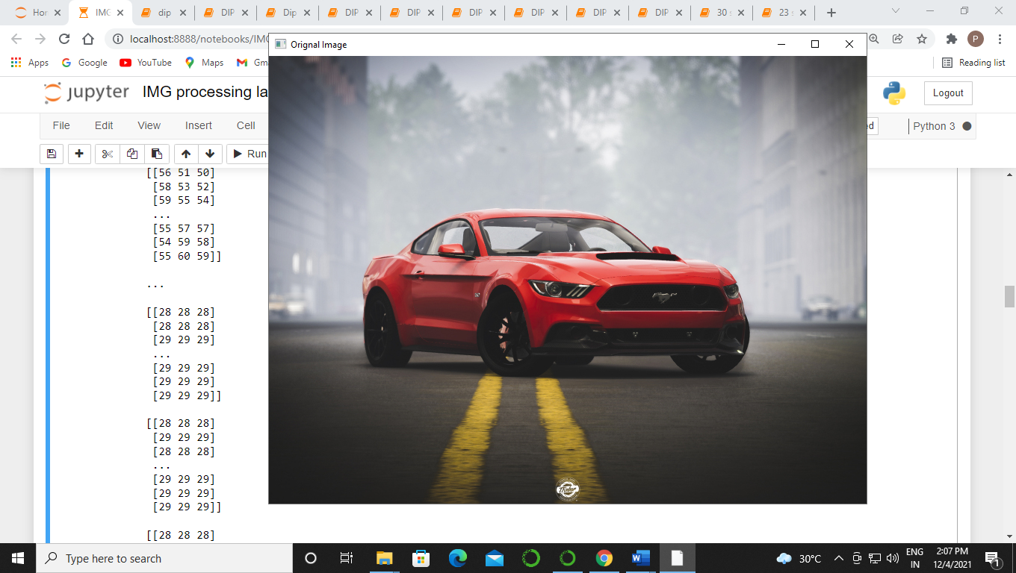

[[[58 53 52]

[59 54 53]

[58 54 53]

...

[53 55 55]

[55 57 57]

[55 60 59]]

[[57 52 51]

[59 54 53]

[59 55 54]

...

[54 56 56]

[56 58 58]

[55 60 59]]

[[56 51 50]

[58 53 52]

[59 55 54]

...

[55 57 57]

[54 59 58]

[55 60 59]]

...

[[28 28 28]

[28 28 28]

[29 29 29]

...

[29 29 29]

[29 29 29]

[29 29 29]]

[[28 28 28]

[29 29 29]

[28 28 28]

...

[29 29 29]

[29 29 29]

[29 29 29]]

[[28 28 28]

[29 29 29]

[28 28 28]

...

[29 29 29]

[29 29 29]

[29 29 29]]]

<class 'numpy.ndarray'>

Q2. Write a python program for writing a image and also display image in a window and the type of image using opencv.

Sol:-

import cv2

img=cv2.imread("D:/IMG processing lab/ford-mustang-the-crew-2-4k.jpg")

print(img)

print(type(img))

cv2.imshow('Orignal Image',img)

ab=img

cv2.imwrite("D:/IMG processing lab/otp1.jpg",ab)

cv2.imread("D:/IMG processing lab/otp1.jpg")

print(ab)

cv2.imshow('Lab img',ab)

cv2.waitKey(0)

Output:-

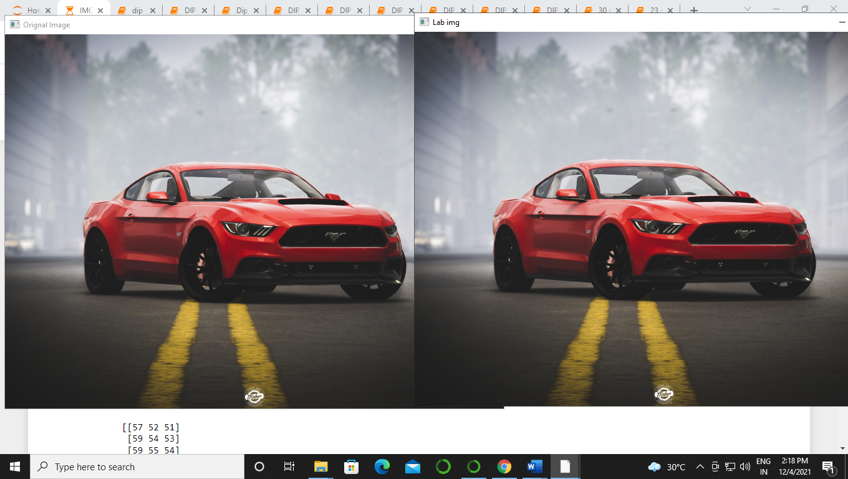

[[[58 53 52]

[59 54 53]

[58 54 53]

...

[53 55 55]

[55 57 57]

[55 60 59]]

[[57 52 51]

[59 54 53]

[59 55 54]

...

[54 56 56]

[56 58 58]

[55 60 59]]

[[56 51 50]

[58 53 52]

[59 55 54]

...

[55 57 57]

[54 59 58]

[55 60 59]]

...

[[28 28 28]

[28 28 28]

[29 29 29]

...

[29 29 29]

[29 29 29]

[29 29 29]]

[[28 28 28]

[29 29 29]

[28 28 28]

...

[29 29 29]

[29 29 29]

[29 29 29]]

[[28 28 28]

[29 29 29]

[28 28 28]

...

[29 29 29]

[29 29 29]

[29 29 29]]]

<class 'numpy.ndarray'>

[[[58 53 52]

[59 54 53]

[58 54 53]

...

[53 55 55]

[55 57 57]

[55 60 59]]

[[57 52 51]

[59 54 53]

[59 55 54]

...

[54 56 56]

[56 58 58]

[55 60 59]]

[[56 51 50]

[58 53 52]

[59 55 54]

...

[55 57 57]

[54 59 58]

[55 60 59]]

...

[[28 28 28]

[28 28 28]

[29 29 29]

...

[29 29 29]

[29 29 29]

[29 29 29]]

[[28 28 28]

[29 29 29]

[28 28 28]

...

[29 29 29]

[29 29 29]

[29 29 29]]

[[28 28 28]

[29 29 29]

[28 28 28]

...

[29 29 29]

[29 29 29]

[29 29 29]]]

Q3. Write a python program for grayscale of image and show the image type and display image

in window.

Code:-

import cv2

img=cv2.imread("D:/IMG processing lab/ford-mustang-the-crew-2-4k.jpg",0)

print(img)

print(type(img))

cv2.imshow('Grayscale Image',img)

cv2.waitKey(0)

Output:-

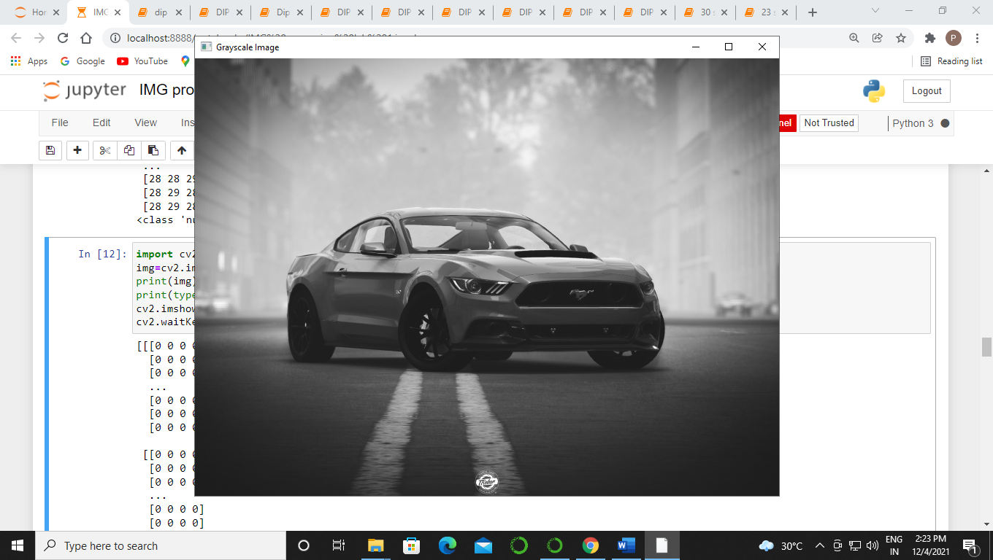

[[53 54 54 ... 55 57 59]

[52 54 55 ... 56 58 59]

[51 53 55 ... 57 58 59]

...

[28 28 29 ... 29 29 29]

[28 29 28 ... 29 29 29]

[28 29 28 ... 29 29 29]]

<class 'numpy.ndarray'>

Q4. Write a python program for transparency image and show the image type and display

image in window.

Code:-

import cv2

img=cv2.imread("D:/IMG processing lab/ford-mustang-the-crew-2-4k.jpg",0)

print(img)

print(type(img))

cv2.imshow('Grayscale Image',img)

cv2.waitKey(0)

Output:-

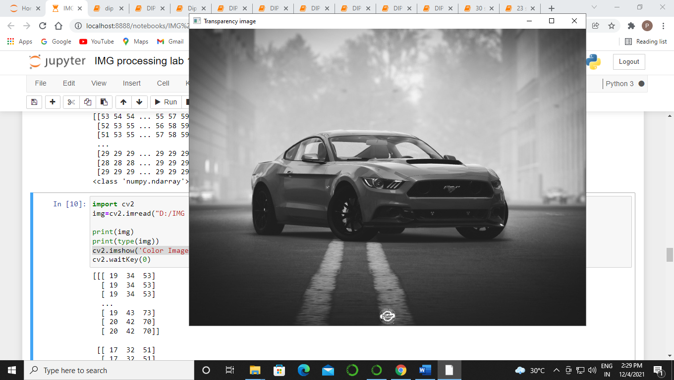

[[53 54 54 ... 55 57 59]

[52 54 55 ... 56 58 59]

[51 53 55 ... 57 58 59]

...

[28 28 29 ... 29 29 29]

[28 29 28 ... 29 29 29]

[28 29 28 ... 29 29 29]]

<class 'numpy.ndarray'>

Q5. Write a python program for color image and show the image type and display

image in window.

Code:-

import cv2

img=cv2.imread("D:/IMG processing lab/ford-mustang-the-crew-2-4k.jpg",1)

cv2.imshow("color image",img)

print(img)

print(type(img))

cv2.waitKey(0)

Output:-

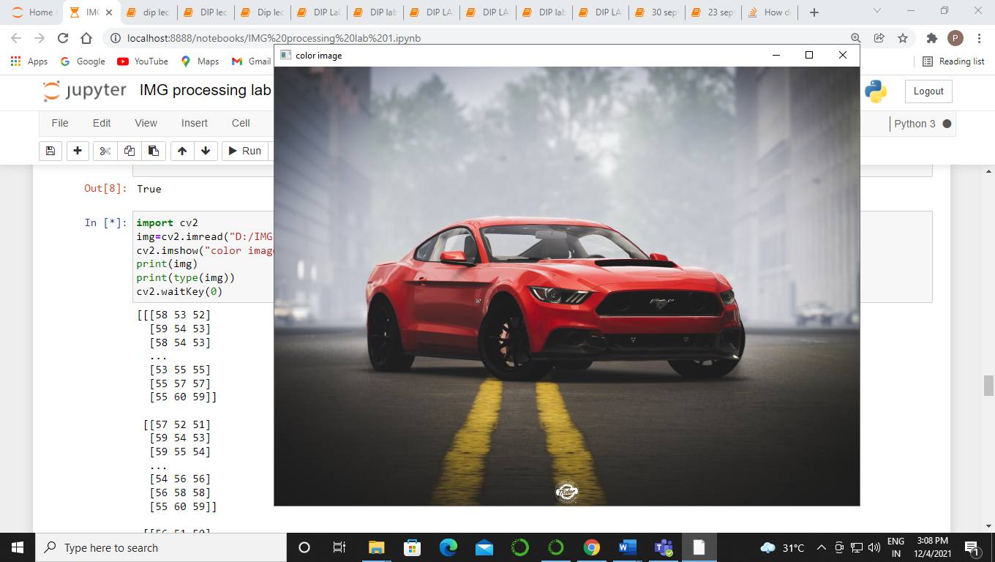

[[[58 53 52]

[59 54 53]

[58 54 53]

...

[53 55 55]

[55 57 57]

[55 60 59]]

[[57 52 51]

[59 54 53]

[59 55 54]

...

[54 56 56]

[56 58 58]

[55 60 59]]

[[56 51 50]

[58 53 52]

[59 55 54]

...

[55 57 57]

[54 59 58]

[55 60 59]]

...

[[28 28 28]

[28 28 28]

[29 29 29]

...

[29 29 29]

[29 29 29]

[29 29 29]]

[[28 28 28]

[29 29 29]

[28 28 28]

...

[29 29 29]

[29 29 29]

[29 29 29]]

[[28 28 28]

[29 29 29]

[28 28 28]

...

[29 29 29]

[29 29 29]

[29 29 29]]]

<class 'numpy.ndarray'>

Q6. Write a Python program to concatenate 2 image in a single window

Code:-

import cv2

import numpy as np

# Read First Image

img1 = cv2.imread('D:/IMG processing lab/resizeimg.jpg')

# Read Second Image

img2 = cv2.imread('D:/IMG processing lab/resizeimg.jpg')

Hori = np.concatenate((img1, img2), axis=1)

cv2.imshow('HORIZONTAL', Hori)

cv2.waitKey(0)

cv2.destroyAllWindows()

Output:-

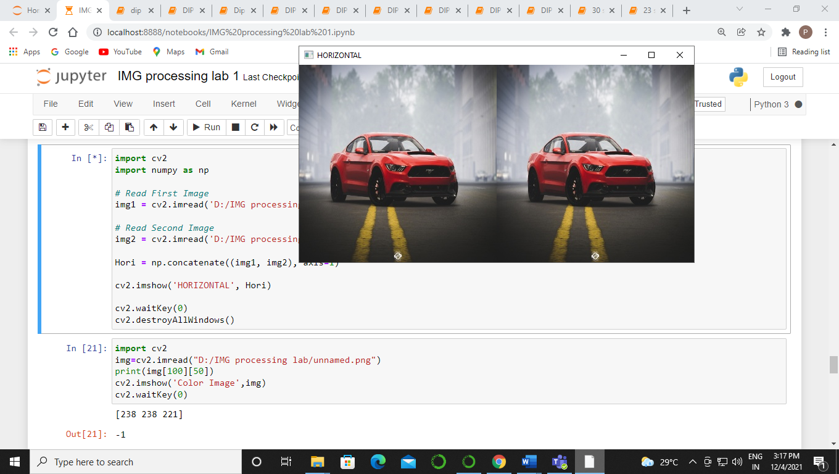

Q7. Write a Python program for accessing the pixel of the Color, grayscale & Transparent

images using opencv.

Code:-

import cv2

img=cv2.imread("D:/IMG processing lab/resizeimg.jpg")

x=img[100][168]

print(x)

cv2.waitKey(0)

Output:-

[209 207 199]

-1

Code:-

import cv2

img=cv2.imread("D:/IMG processing lab/resizeimg.jpg",0)

print(img[100][50])

cv2.waitKey(0)

Output:-

232

-1

Code:-

import cv2

img=cv2.imread("D:/IMG processing lab/resizeimg.jpg",-1)

print(img[100][50])

cv2.waitKey(0)

Output:-

[238 238 221]

-1

Q8. Write a Python program to print the BGR values of an image using opencv

Code:-

import cv2

import numpy as np

img=cv2.imread("D:/IMG processing lab/resizeimg.jpg")

px=img[100,100]

print(px)

blue=img[100,100,0]

print("Blue:-",blue)

green=img[100,100,1]

print("Green:-",green)

red=img[100,100,2]

print("Red:-",red)

Output:-

[206 200 195]

Blue:- 206

Green:- 200

Red:- 195

Q9. Write a Python program to print height width and channels of an image also print the pixel

of an image in respect to height and width.

Code:-

import cv2

img=cv2.imread("D:/IMG processing lab/resizeimg.jpg")

h, w, c = img.shape

print("height :- " ,h)

print("width :- " ,w)

print("channels :- " ,c)

for i in range(h) :

print(img[i,0])

for i in range(w) :

print(img[0,i])

Output:-

height :- 320

width :- 320

channels :- 3

For height:-

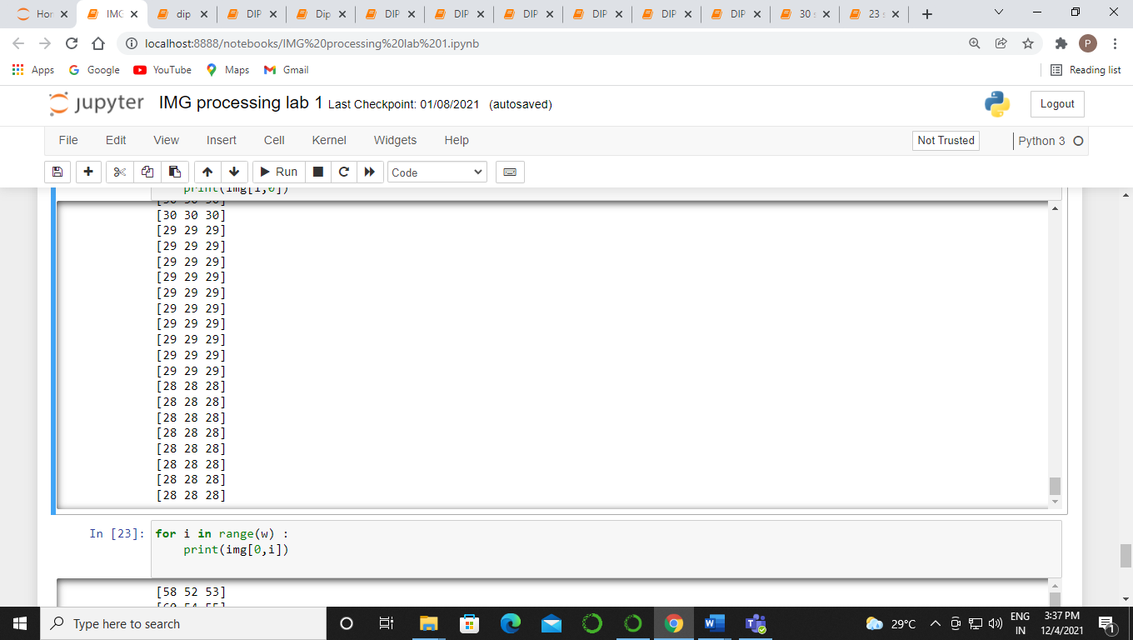

For width:-

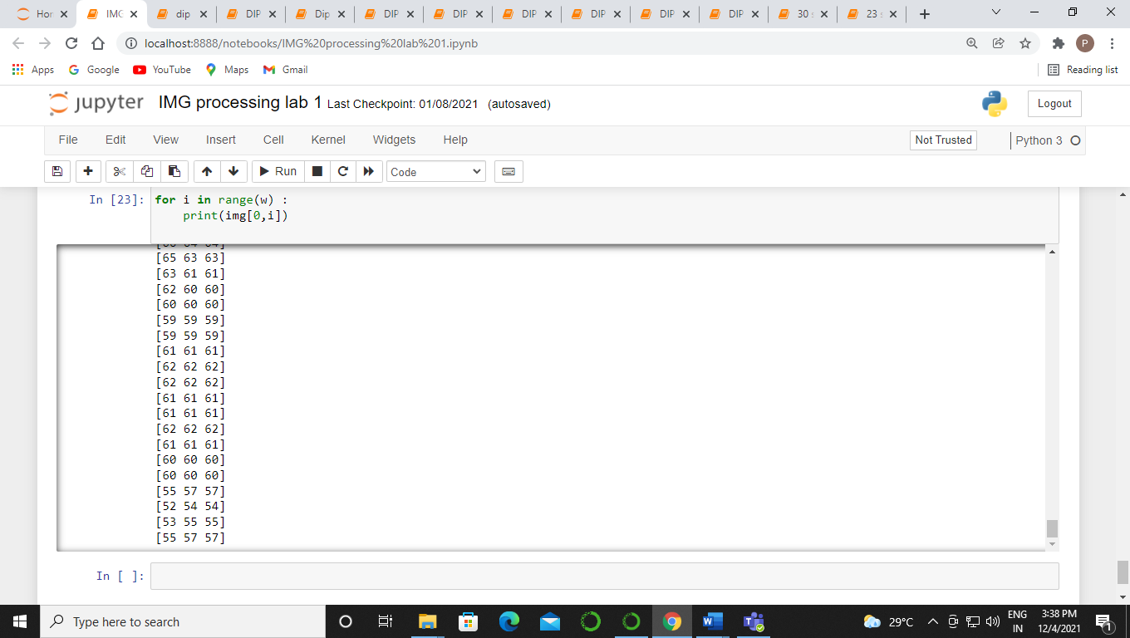

Q10. Write a Python program for negative transformation of an image using oepncv

Code:-

import cv2

import numpy as np

img=cv2.imread('D:/IMG processing lab/resizeimg.jpg',0)

l=256

s=(l-1)-img

con = np.concatenate((img, s), axis=1)

cv2.imshow('Output:-', con)

cv2.waitKey(0)

Output:-

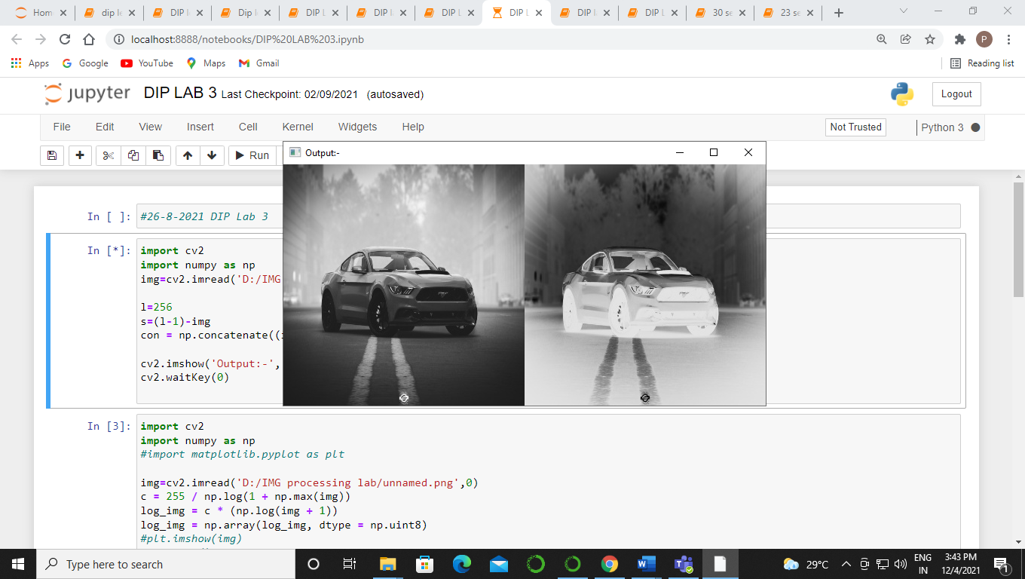

Q11. Write a Python program for log transformation of an image using opencv

Code:-

import cv2

import numpy as np

#import matplotlib.pyplot as plt

img=cv2.imread('D:/IMG processing lab/resizeimg.jpg',0)

c = 255 / np.log(1 + np.max(img))

log_img = c * (np.log(img + 1))

log_img = np.array(log_img, dtype = np.uint8)

cv2.imshow('orignal', img)

cv2.imshow('log trans image', log_img)

cv2.waitKey(0)

Output:-

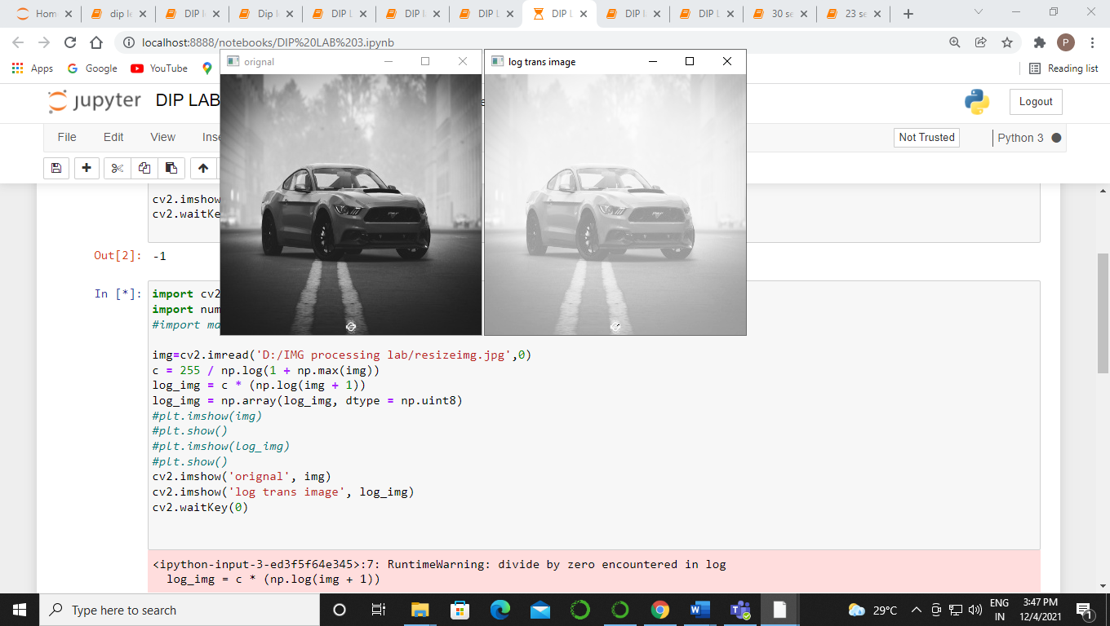

Q12. Write a Python program for power law transformation (gamma transformation) using

opencv

Code:-

import numpy as np

import cv2

# Load the image

img = cv2.imread('D:/IMG processing lab/resizeimg.jpg')

gamma_ten = np.array(255*(img/255)**10,dtype='uint8')

gamma_eigth = np.array(255*(img/255)**8,dtype='uint8')

gamma_six = np.array(255*(img/255)**6,dtype='uint8')

cv2.imshow('orignal image',img)

cv2.imshow('gamma value 10',gamma_ten)

cv2.imshow('gamma value 8',gamma_eigth)

cv2.imshow('gamma value 6',gamma_six)

cv2.waitKey(0)

Output:-

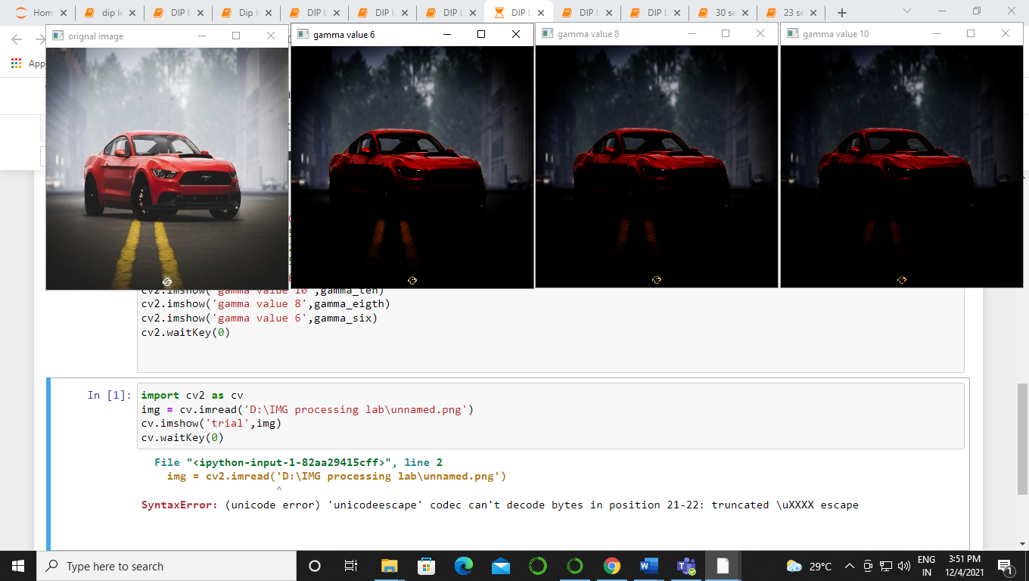

Q13. Write a Python program for histogram analysis of an image using opencv

Code:-

import cv2 as cv

import numpy as np

from matplotlib import pyplot as plt

img = cv.imread('D:/IMG processing lab/Circle.png')

hist = cv.calcHist([img],[0],None,[256],[0,256])

plt.hist(img.ravel(),256,[0,256]);

plt.show()

cv.imshow('gg:-',img)

cv.waitKey(0)

Output:-

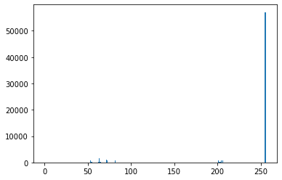

Q14. Write a Python program for applying threshold binary on an image using opencv

Code:-

#cv.THRESH_BINARY

import cv2 as cv

img = cv.imread("D:\\IMG processing lab\\Circle.png",0)

cv.imshow('Og img:-',img)

ret_val, res_thr_binary = cv.threshold(img, 100, 255, cv.THRESH_BINARY)

cv.imwrite('D:\\IMG processing lab\\Circle1.png',res_thr_binary)

cv.imshow('Output:-',res_thr_binary)

cv.waitKey(0)

Output:-

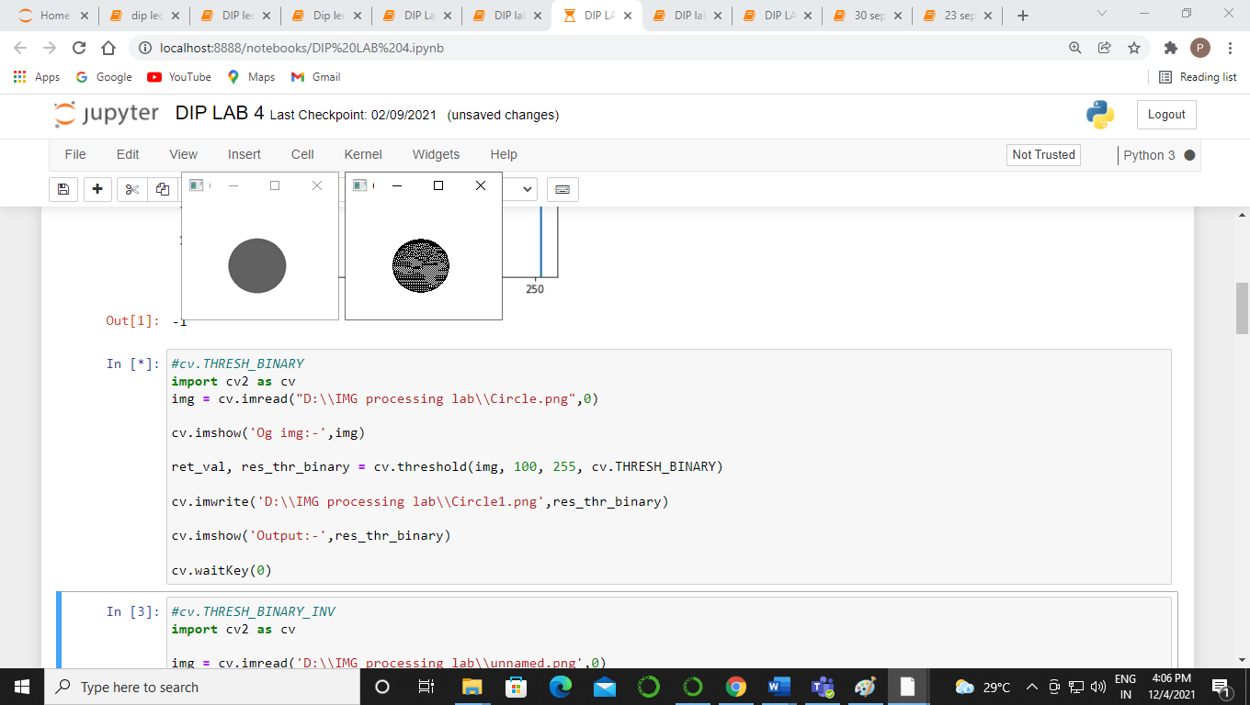

Q15. Write a Python program for applying threshold BINARY_INV on an image using opencv

Code:-

#cv.THRESH_BINARY_INV

import cv2 as cv

img = cv.imread('D:\\IMG processing lab\\Circle.png',0)

cv.imshow('Og img:-',img)

ret_val, res_thr_binary_inv = cv.threshold(img, 100, 255, cv.THRESH_BINARY_INV)

cv.imwrite('D:\\IMG processing lab\\Circle2.png',res_thr_binary_inv)

cv.imshow('Output:-',res_thr_binary_inv)

cv.waitKey(0)

Output:-

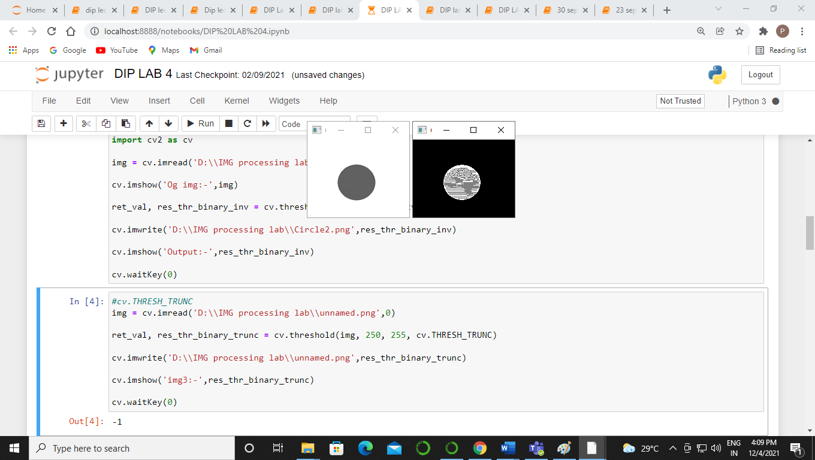

Q16. Write a Python program for applying threshold TRUNC on an image using opencv

Code:-

#cv.THRESH_TRUNC

import cv2 as cv

img = cv.imread('D:\\IMG processing lab\\Circle.png',0)

cv.imshow('Og img:-',img)

ret_val, res_thr_binary_trunc = cv.threshold(img, 250, 255, cv.THRESH_TRUNC)

cv.imwrite('D:\\IMG processing lab\\Circle3.png',res_thr_binary_trunc)

cv.imshow('Output:-:-',res_thr_binary_trunc)

cv.waitKey(0)

Output:-

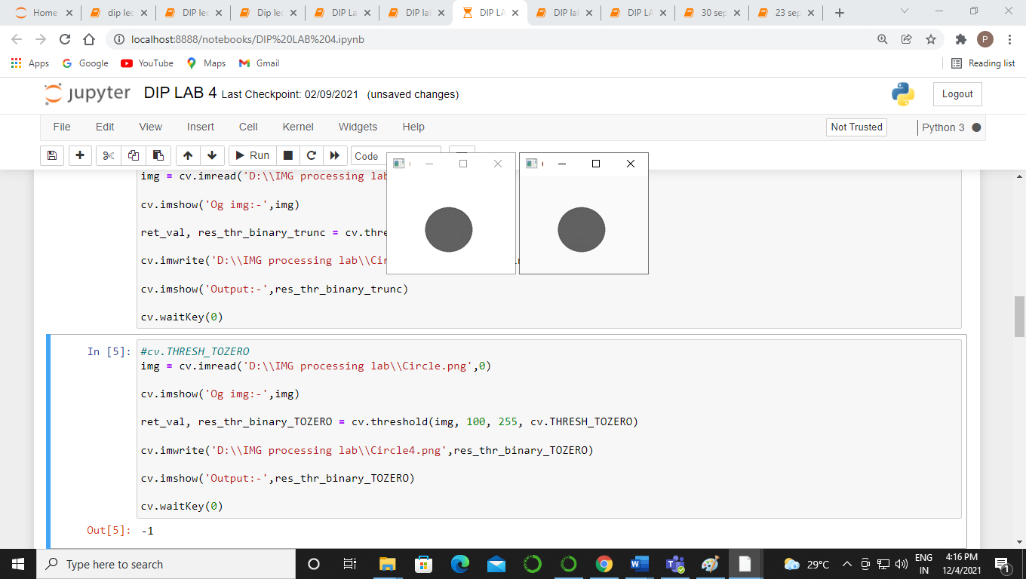

Q17. Write a Python program applying threshold TOZERO on an image using opencv

Code:-

#cv.THRESH_TOZERO

import cv2 as cv

img = cv.imread('D:\\IMG processing lab\\Circle.png',0)

cv.imshow('Og img:-',img)

ret_val, res_thr_binary_TOZERO = cv.threshold(img, 100, 255, cv.THRESH_TOZERO)

cv.imwrite('D:\\IMG processing lab\\Circle4.png',res_thr_binary_TOZERO)

cv.imshow('Output:-',res_thr_binary_TOZERO)

cv.waitKey(0)

Output:-

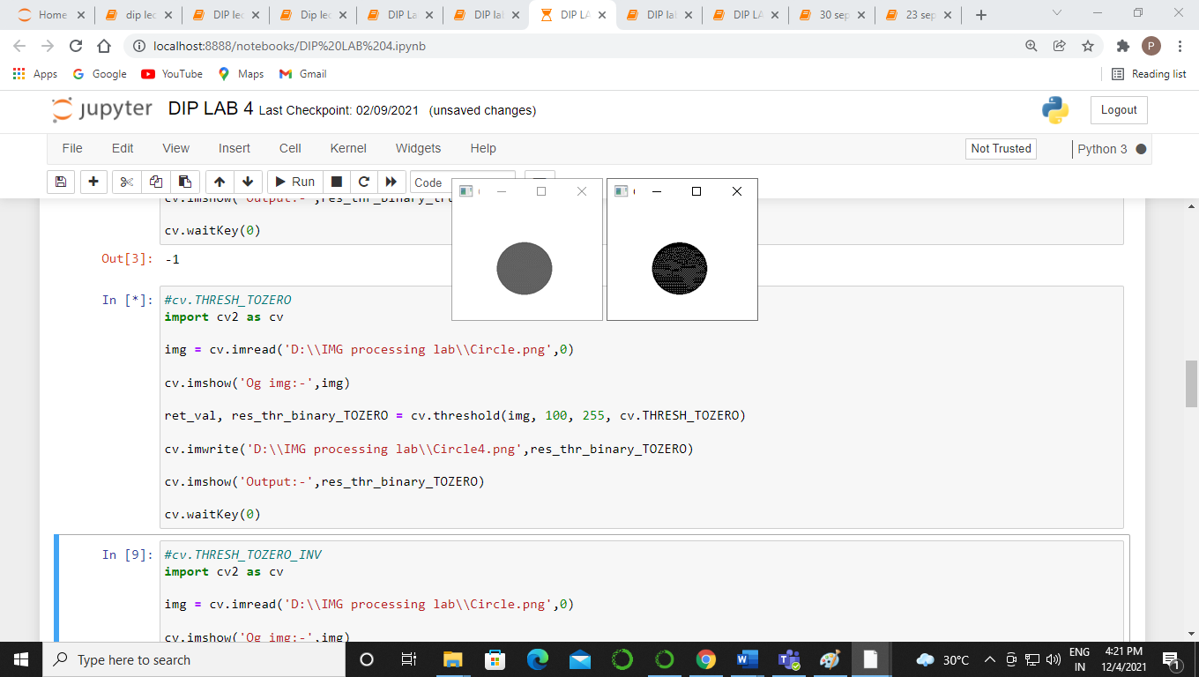

Q18. Write a Python program applying threshold TOZERO_INV on an image using opencv

Code:-

#cv.THRESH_TOZERO_INV

import cv2 as cv

img = cv.imread('D:\\IMG processing lab\\Circle.png',0)

cv.imshow('Og img:-',img)

ret_val, res_thr_binary_TOZERO_INV = cv.threshold(img, 100, 255, cv.THRESH_TOZERO_INV)

cv.imwrite('D:\\IMG processing lab\\Circle5.png',res_thr_binary_TOZERO_INV)

cv.imshow('Output:-',res_thr_binary_TOZERO_INV)

cv.waitKey(0)

Output:-

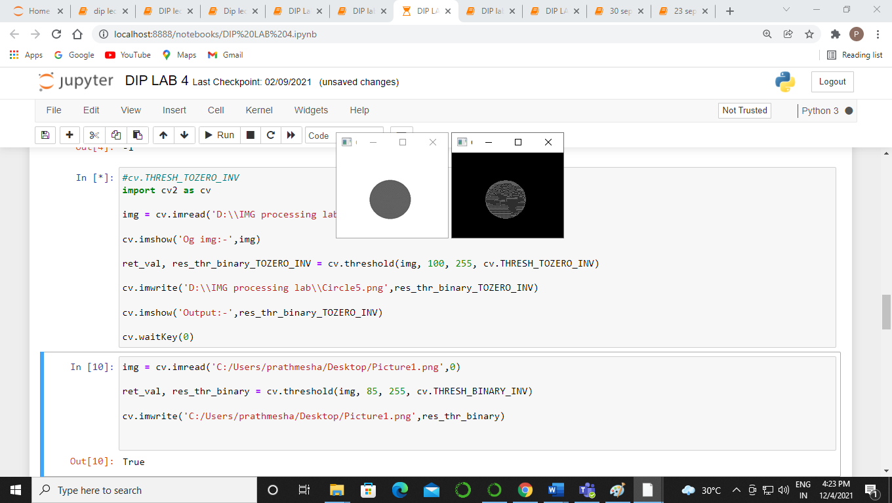

Q19. Write a Python program for circle separation from an image using thresholding by using

opencv

Code:-

#circle separation

import cv2 as cv

img = cv.imread('D:/IMG processing lab/trial.png',0)

cv.imshow('og img:-',img)

ret_val, res_thr_binary = cv.threshold(img, 100, 255, cv.THRESH_BINARY_INV)

cv.imwrite('D:/IMG processing lab/circle rectangle 1.png',res_thr_binary)

cv.imshow('Output:-',res_thr_binary)

cv.waitKey(0)

Output:-

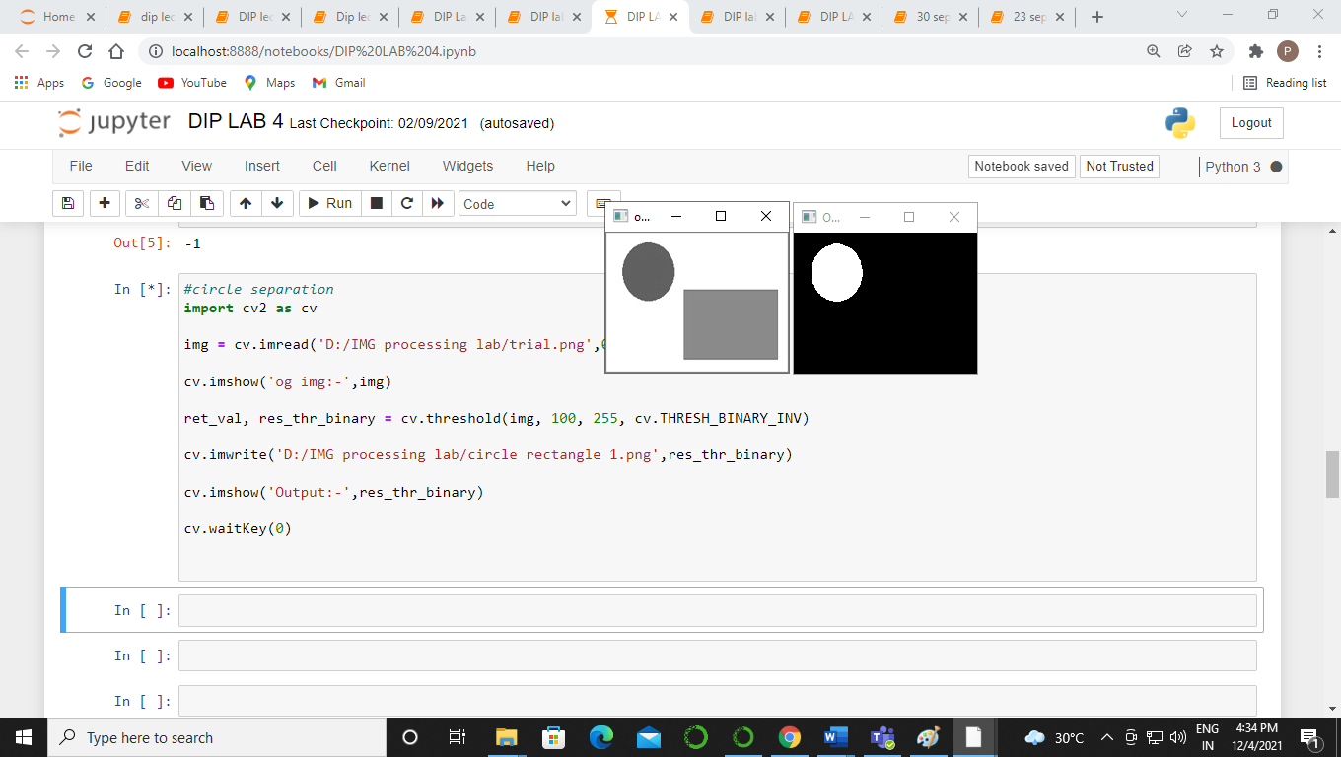

Q20. Write a Python program for separating circle and rectangle from background using

Threshold functions by using opencv

Code:-

#Circle and Rectangle separation

import cv2 as cv

img = cv.imread('D:/IMG processing lab/trial.png',0)

cv.imshow('og img:-',img)

ret_val, res_thr_binary = cv.threshold(img, 150, 255, cv.THRESH_BINARY_INV)

cv.imwrite('D:/IMG processing lab/circle rectangle 2.png',res_thr_binary)

cv.imshow('Output:-',res_thr_binary)

cv.waitKey(0)

Output:-

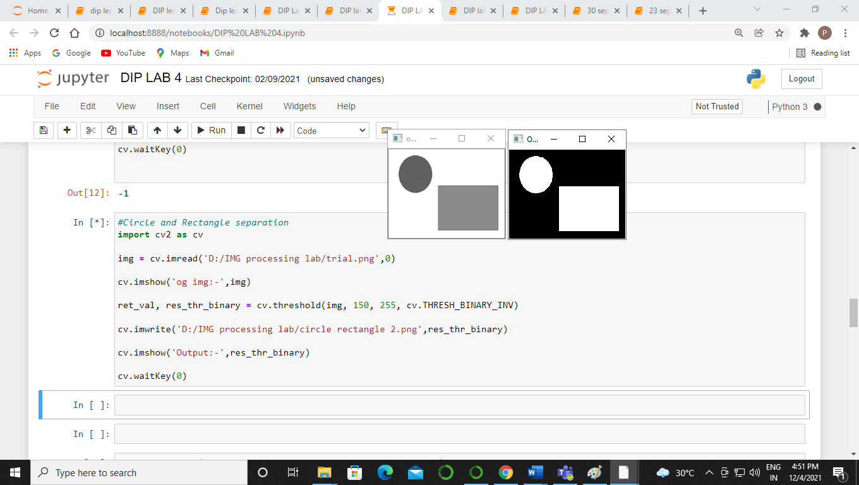

Q21. Write a Python program for separating rectangle using threshold by using opencv

Code:-

#Separating rectangle

import cv2 as cv

img = cv.imread('D:/IMG processing lab/trial.png',0)

cv.imshow("OG img:-",img)

img1=img

for x in range(img1.shape[0]) :

for y in range(img1.shape[1]):

if (img1[x][y]<155 and img1[x][y]>115):

img1[x][y]= 255

else:

img1[x][y]= 0

cv.imwrite('D:/IMG processing lab/rectangle1.png',img1)

cv.imshow("Output:-",img1)

cv.waitKey(0)

Output:-

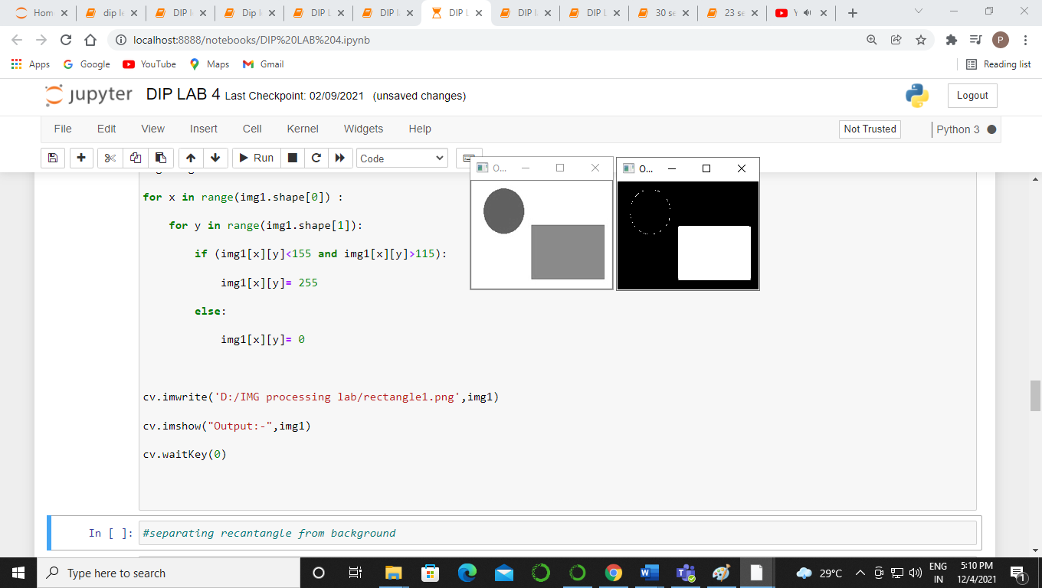

Q22. Write a Python program for separating rectangle from background using threshold by using

opencv.

Code:-

#separating recantangle from background

import cv2 as cv

img = cv.imread('D:/IMG processing lab/trial.png',0)

cv.imshow("OG img:-",img)

img1=img

for x in range(img1.shape[0]) :

for y in range(img1.shape[1]):

if (img1[x][y]<155 and img1[x][y]>115):

img1[x][y]= 0

else:

img1[x][y]= 255

cv.imwrite('D:/IMG processing lab/rectangle1.png',img1)

cv.imshow("Output:-",img1)

cv.waitKey(0)

Output:-

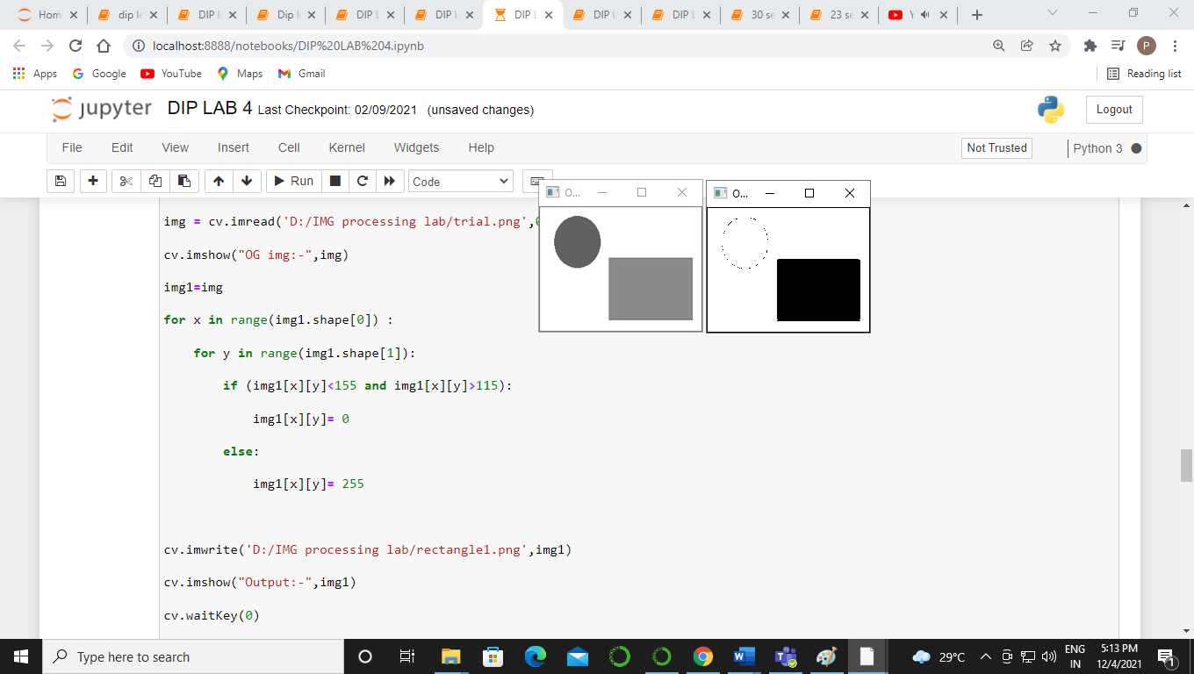

Q23. Write a Python program for edge detection(X direction) using sobel.

Code:-

import numpy as np

import cv2 as cv

img = cv.imread('D:/IMG processing lab/resizeimg.jpg',0)

cv.imshow("Og img:-",img)

sobelx = cv.Sobel(img,-1,1,0,ksize=3)

cv.imshow('output:-',sobelx)

cv.waitKey(0)

Output:-

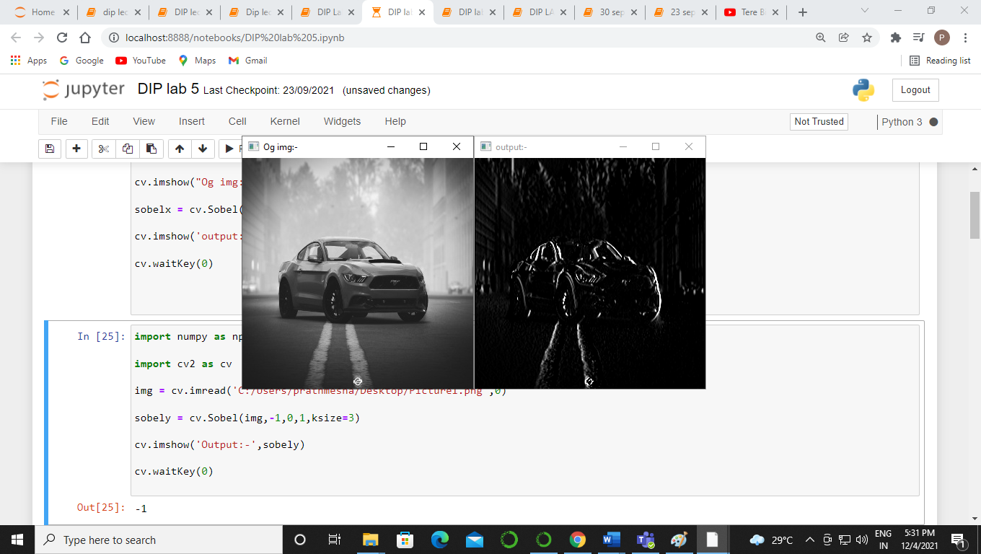

Q24. Write a Python program edge detection(Y direction) using sobel.

Code:-

import numpy as np

import cv2 as cv

img = cv.imread('D:/IMG processing lab/resizeimg.jpg',0)

cv.imshow("Og img:-",img)

sobely = cv.Sobel(img,-1,0,1,ksize=3)

cv.imshow('Output:-',sobely)

cv.waitKey(0)

Output:-

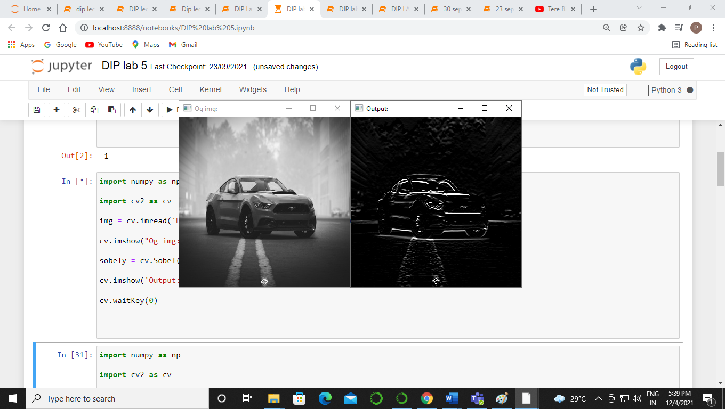

Q25. Write a Python program edge detection(XY direction) using sobel.

Code:-

import numpy as np

import cv2 as cv

img = cv.imread('D:/IMG processing lab/resizeimg.jpg',0)

cv.imshow("Og img:-",img)

sobelxy = cv.Sobel(img,-1,1,1,ksize=3)

cv.imshow('Output:-',sobelxy)

cv.waitKey(0)

Output:-

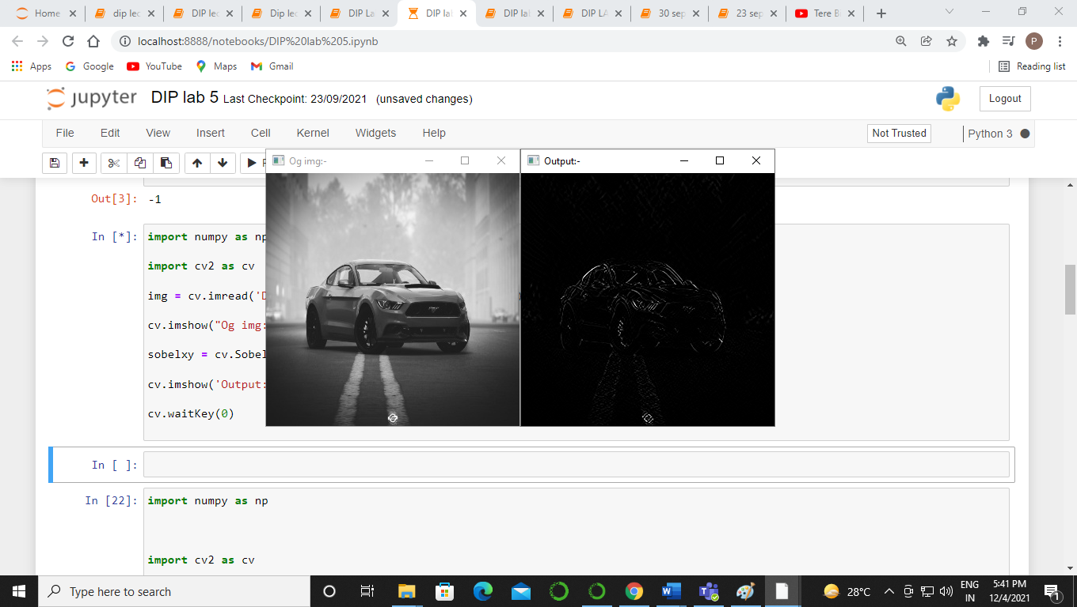

Q26. Write a Python program to find longest line using sobel edge detection.

Code:-

import numpy as np

import cv2 as cv

img =cv.imread("D:\IMG processing lab\MicrosoftTeams-image (2).png",0)

sobely = cv.Sobel(img,-1,0,1,ksize=3)

cv.imwrite('D:\IMG processing lab\MicrosoftTeams-image (2).png',sobely)

print(sobely)

print(sobely.shape)

c=0

ar=[]

ar2=[]

list=[]

for row in range(0,sobely.shape[0]):

for column in range(0,sobely.shape[1]):

if sobely[row][column]==255:

c=c+1

ar.append(row)

if ar2.count(row) < 1:

ar2.append(row)

for i in ar2:

c=ar.count(i)

print(str(i)+" no.of times "+str(c))

list.append(c)

m=max(list)

print("Largest value is :-",max(list))

Output:-

[[0 0 0 ... 0 0 0]

[0 0 0 ... 0 0 0]

[0 0 0 ... 0 0 0]

...

[0 0 0 ... 0 0 0]

[0 0 0 ... 0 0 0]

[0 0 0 ... 0 0 0]]

(208, 511)

73 no.of times 458

117 no.of times 141

162 no.of times 249

Largest value is :- 458

​

Q27. Write a Python program for performing zooming operation using inter cubic function

Code:-

import numpy as np

import cv2 as cv

img = cv.imread('D:/IMG processing lab/Original-Lena-image_Q320.jpg')

cv.imshow('og img',img)

img.shape

height, width, channel = img.shape

res = cv.resize(img,(4*width, 2*height), interpolation = cv.INTER_CUBIC)

cv.namedWindow('res image', cv.WINDOW_NORMAL)

cv.imshow('res image', res)

cv.waitKey(0)

Output:-

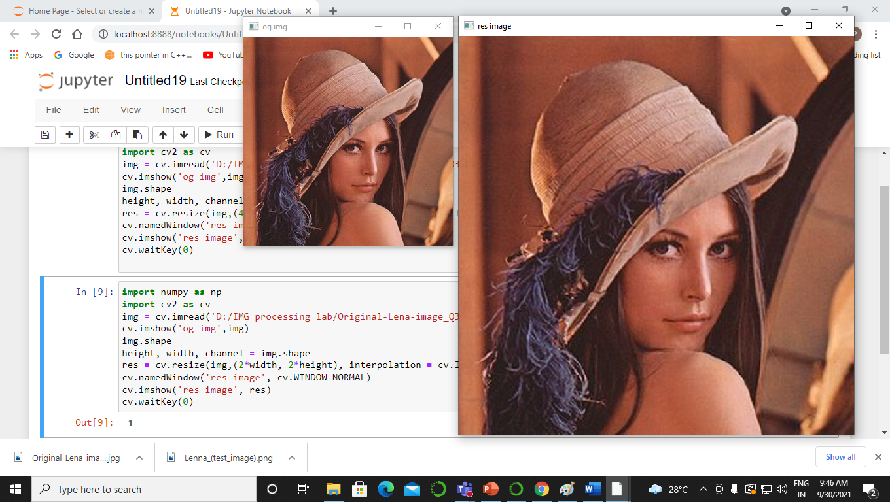

Q28. Write a Python program for performing zooming operation using inter linear function

Code:-

#Zooming 2

import numpy as np

import cv2 as cv

img = cv.imread("D:/IMG processing lab/Original-Lena-image_Q320.jpg")

cv.imshow('og img',img)

img.shape

height, width, channel = img.shape

res = cv.resize(img,(2*width, 2*height), interpolation = cv.INTER_LINEAR)

cv.namedWindow('res image', cv.WINDOW_NORMAL)

cv.imshow('res image', res)

cv.waitKey(0)

Output:-

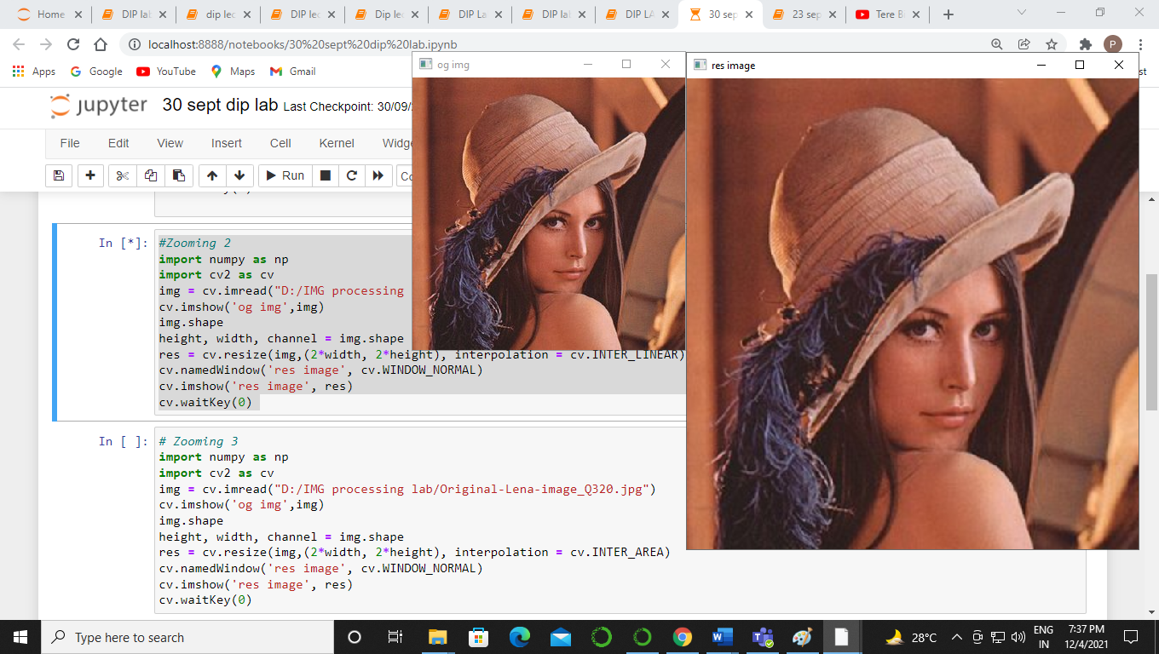

Q29. Write a Python program for performing zooming operation using inter area function

Code:-

# Zooming 3

import numpy as np

import cv2 as cv

img = cv.imread("D:/IMG processing lab/Original-Lena-image_Q320.jpg")

cv.imshow('og img',img)

img.shape

height, width, channel = img.shape

res = cv.resize(img,(2*width, 2*height), interpolation = cv.INTER_AREA)

cv.namedWindow('res image', cv.WINDOW_NORMAL)

cv.imshow('res image', res)

cv.waitKey(0)

Output:-

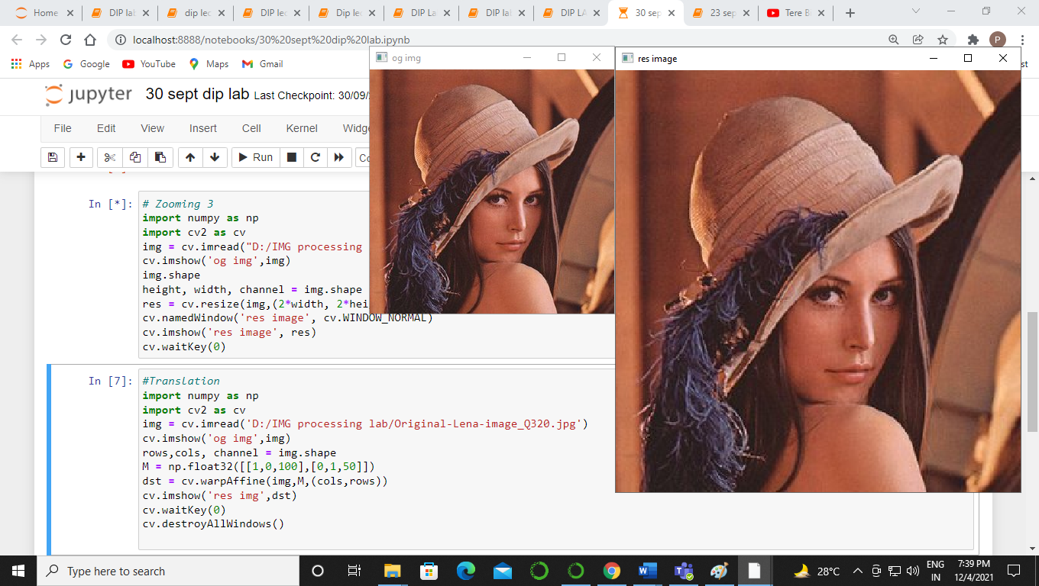

Q30. Write a Python program for translation of an image using opencv

Code:-

import numpy as np

import cv2 as cv

img = cv.imread('D:/IMG processing lab/Original-Lena-image_Q320.jpg')

cv.imshow('og img',img)

rows,cols, channel = img.shape

M = np.float32([[1,0,100],[0,1,50]])

dst = cv.warpAffine(img,M,(cols,rows))

cv.imshow('res img',dst)

cv.waitKey(0)

cv.destroyAllWindows()

Output:-

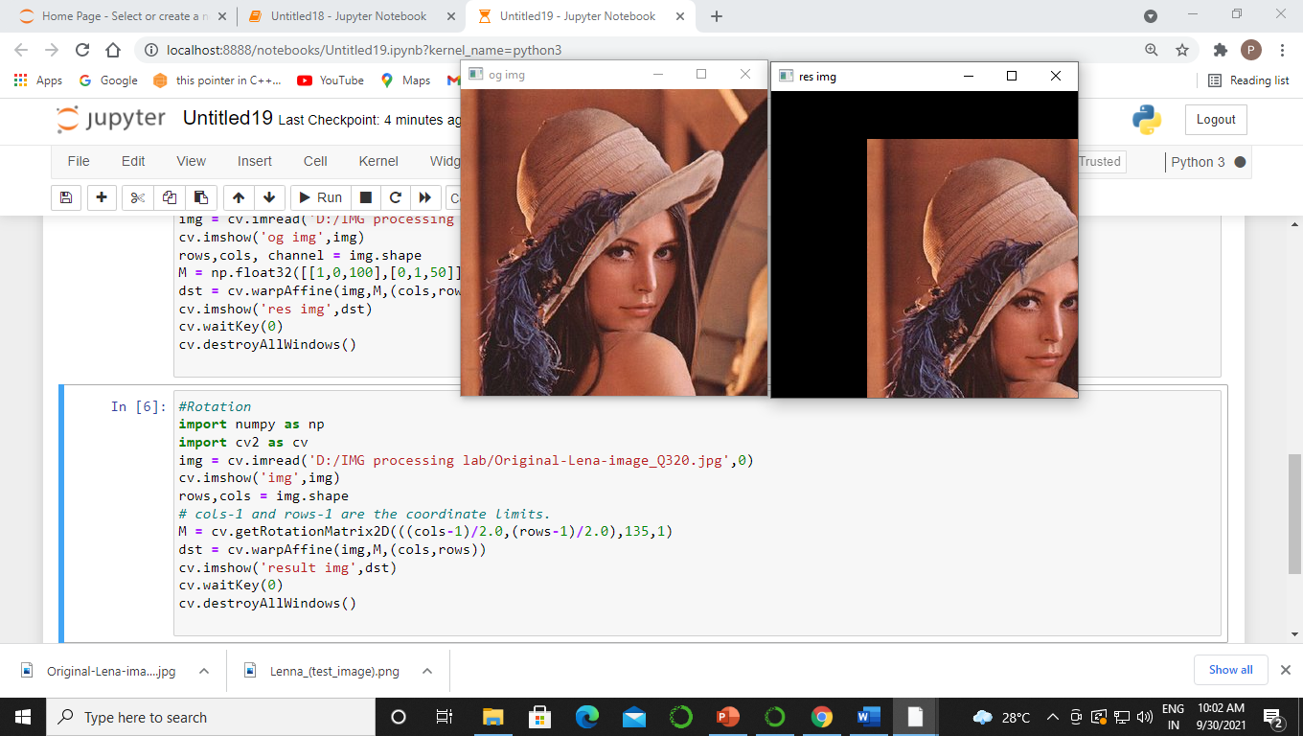

Q31. Write a Python program for rotation of a image using opencv

Code:-

import numpy as np

import cv2 as cv

img = cv.imread('D:/IMG processing lab/Original-Lena-image_Q320.jpg',0)

cv.imshow('img',img)

rows,cols = img.shape

# cols-1 and rows-1 are the coordinate limits.

M = cv.getRotationMatrix2D(((cols-1)/2.0,(rows-1)/2.0),135,1)

dst = cv.warpAffine(img,M,(cols,rows))

cv.imshow('result img',dst)

cv.waitKey(0)

cv.destroyAllWindows()

Output:-

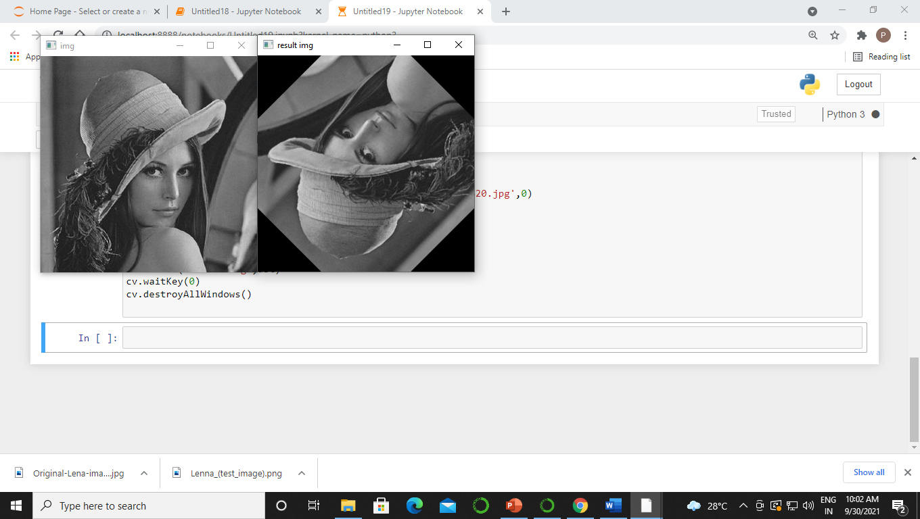

Q32. Write a Python program for hough line transformation.

Code:-

import cv2

import os

import numpy as np

img = cv2.imread('D:/IMG processing lab/image2.png')

cv2.imshow('Input:-',img)

edges = cv2.Canny(img, 50, 200)

lines = cv2.HoughLinesP(edges, 1, np.pi/180, 100, minLineLength=10, maxLineGap=250)

for line in lines:

x1, y1, x2, y2 = line[0]

cv2.line(img, (x1, y1), (x2, y2), (255, 0, 0), 3)

cv2.imshow("Result Image", img)

cv2.waitKey(0)

Output:-

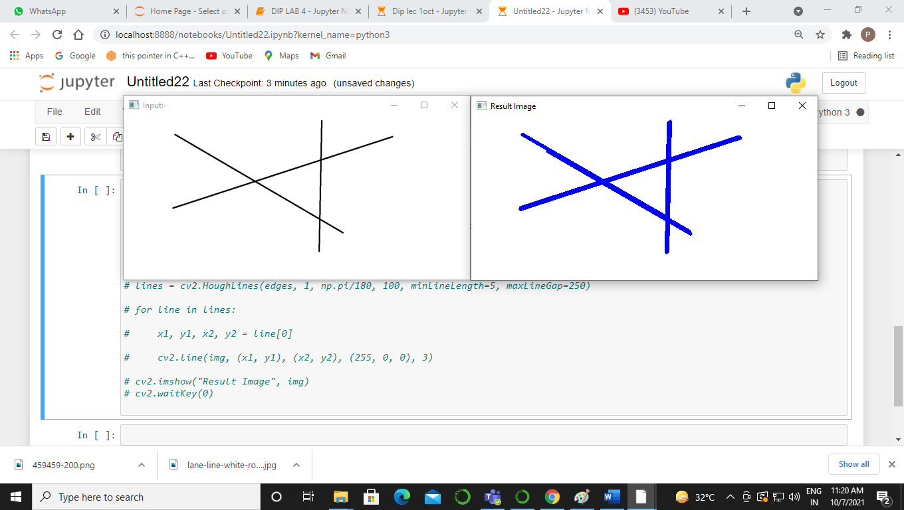

Q33. Write a Python program for capturing frames from a video

Code:-

import os

import cv2

c=0

cam=cv2.VideoCapture("C:/Users/prathmesha/Downloads/Meeting in _General_-20211006_142405-Meeting Recording.mp4")

x=0

while x<5:

x+=1

c+=5000

cam.set(cv2.CAP_PROP_POS_MSEC,c)

ret,frame= cam.read()

cv2.imwrite("D:/IMG processing lab/s"+str(x)+".jpg",frame)

cv2.destroyAllWindows()

Output:-

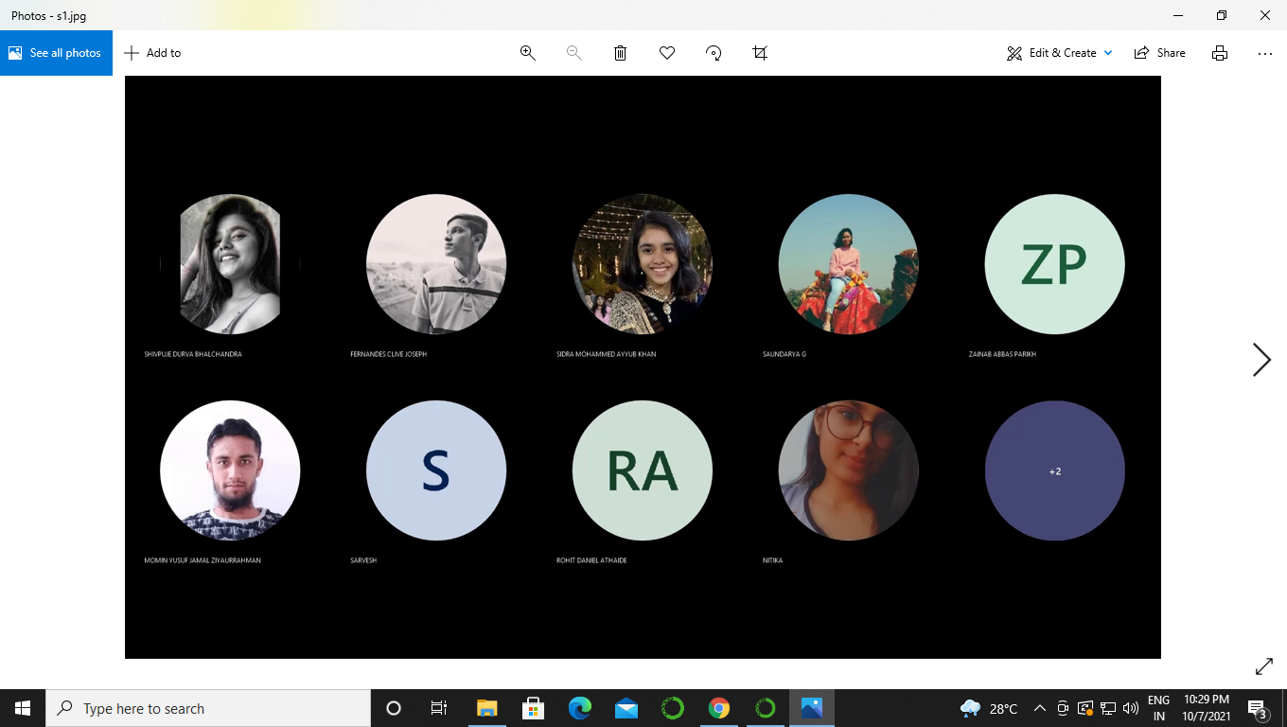

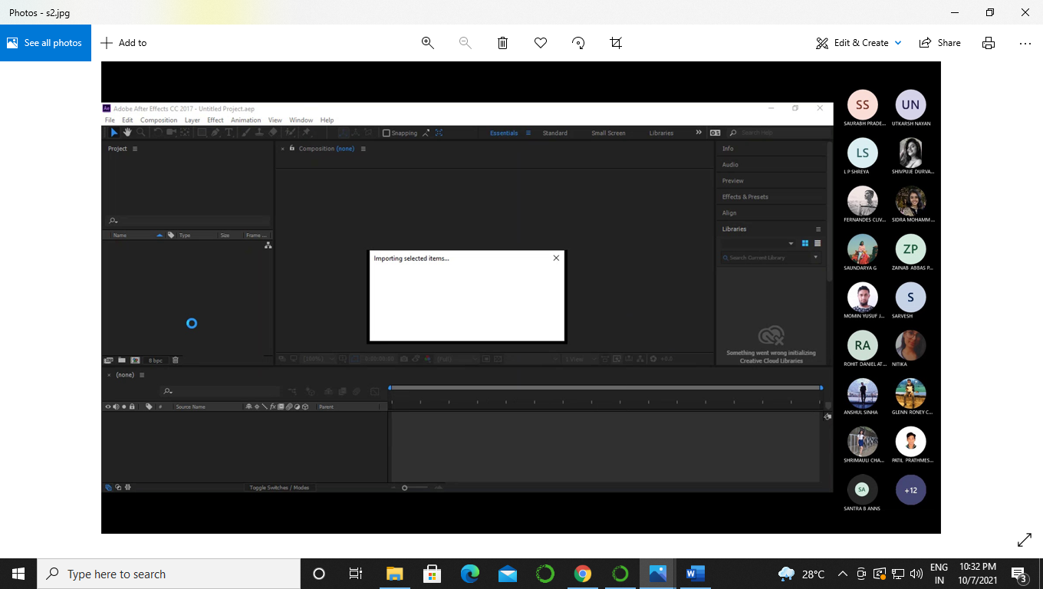

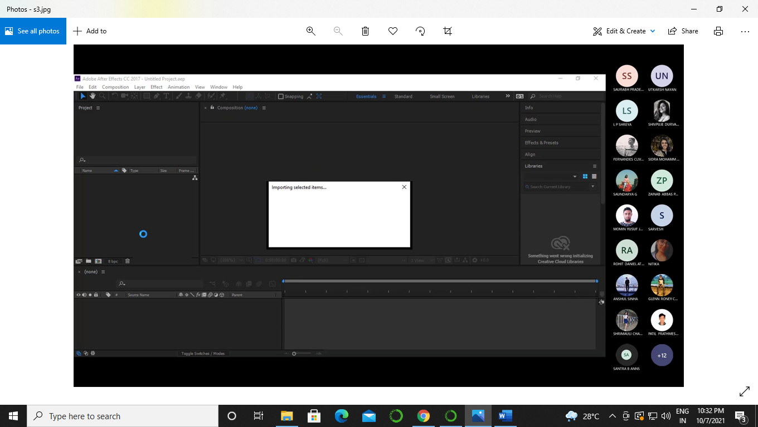

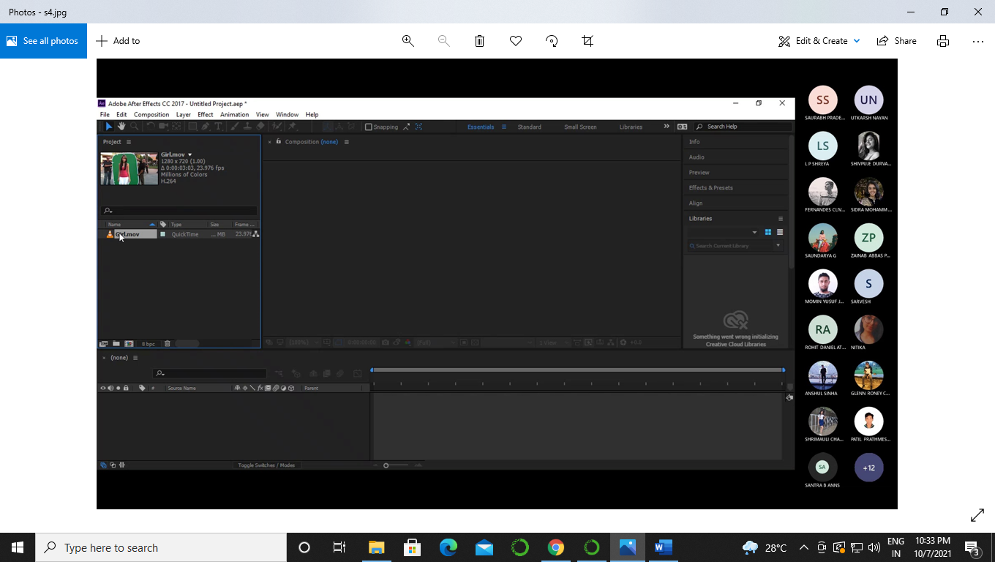

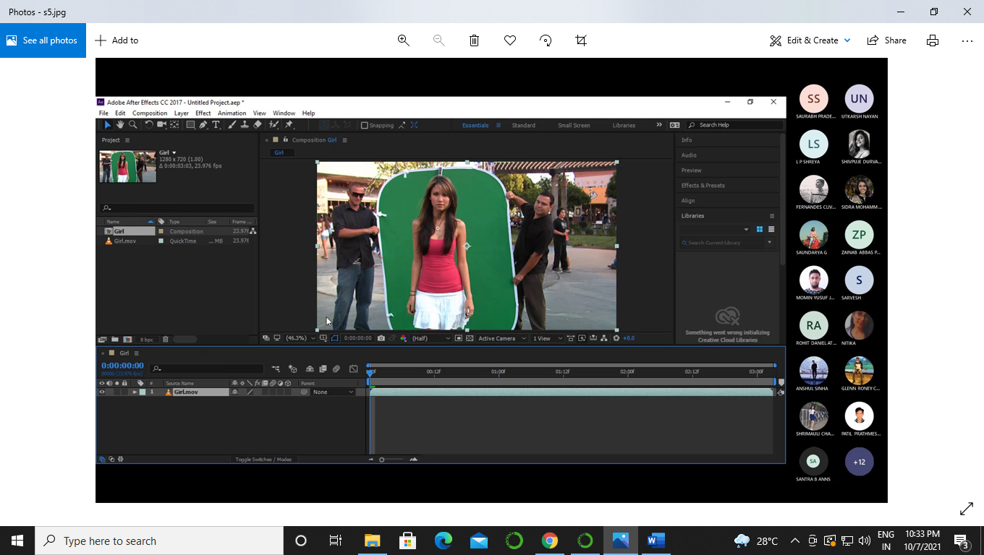

Q34. Write a Python program for video writer.

Code:-

import numpy as np

import cv2 as cv

cap = cv.VideoCapture(0)

# Define the codec and create VideoWriter object

fourcc = cv.VideoWriter_fourcc(*'XVID')

out = cv.VideoWriter('C:/Users/prathmesha/Desktop/output/myvideo.avi', fourcc, 20.0, (640, 480))

while cap.isOpened():

ret, frame = cap.read()

if not ret:

print("Can't receive frame (stream end?). Exiting ...")

break

out.write(frame)

cv.imshow('frame', frame)

if cv.waitKey(1) == ord('q'):

break

# Release everything if job is finished

cap.release()

out.release()

cv.destroyAllWindows()

Output:-

Q35. Write a Python program to make video from a sequence of an images

Code:-

import os

import cv2

import numpy as np

img = cv2.imread("

print(img.shape())

vd=cv2.VideoWriter("C:/Users/prathmesha/Desktop/output/video2.mp4",cv2.VideoWriter_fourcc(*'MJPG'), 10, size)

img1 = cv2.imread("D:/IMG processing lab/pngtree-cool-lightning-background-promotion-main-map-image_155563.jpg")

print(img1.shape())

img2 = cv2.imread("D:/IMG processing lab/6163542.jpg")

print(img2.shape())

vd.write(img)

vd.write(img1)

vd.write(img2)

vd.write(img1)

vd.write(img)

cv2.destroyAllWindows()

vd.release()

Output:-

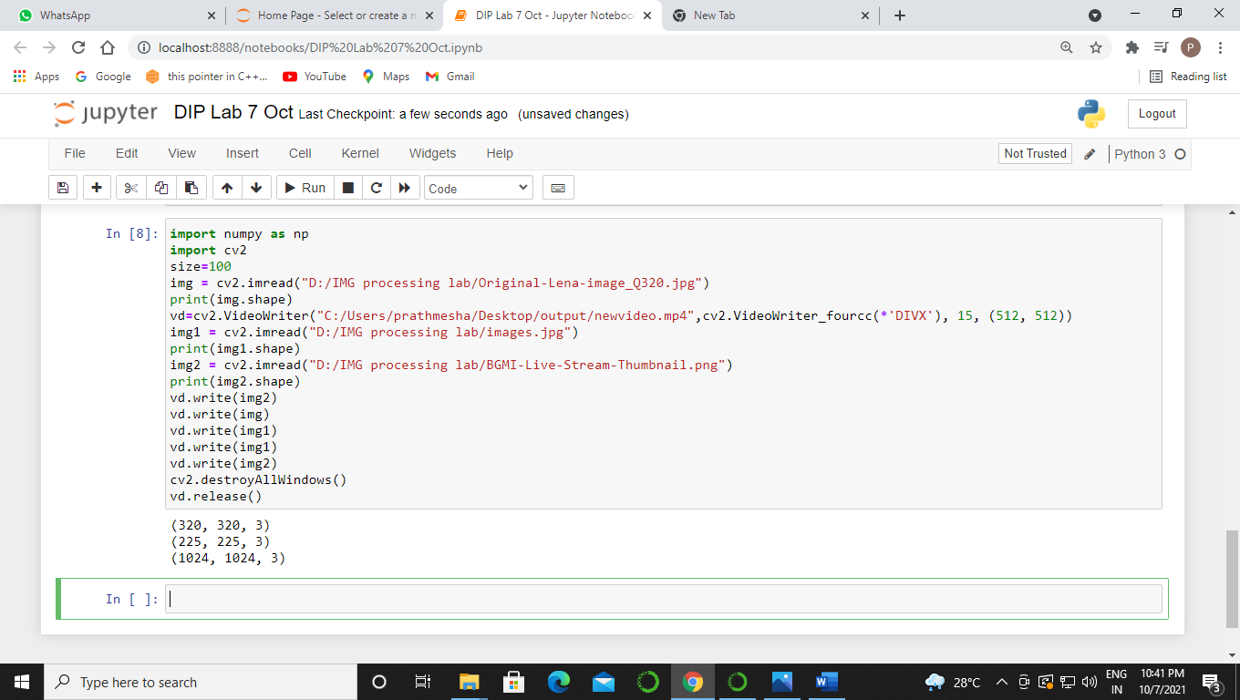

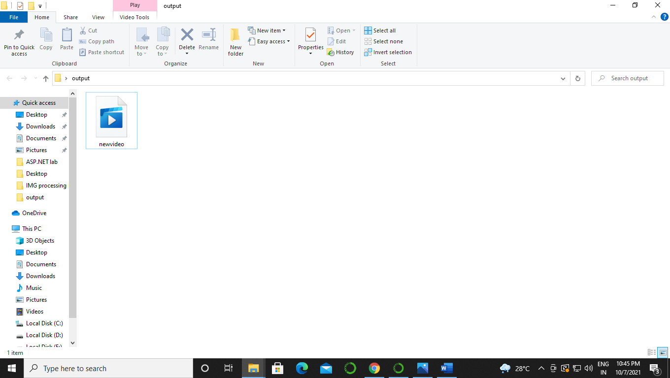

Q36. Write a Python program for denoising of a noised image.

Code:-

import numpy as np

import cv2

img = cv2.imread('D:/IMG processing lab/noised image.jpg')

cv2.imshow('img:-',img)

# Denoising

dst = cv2.fastNlMeansDenoisingColored(img,None,10,10,7,21)

cv2.imshow("image", dst)

cv2.waitKey(0)

Output:-

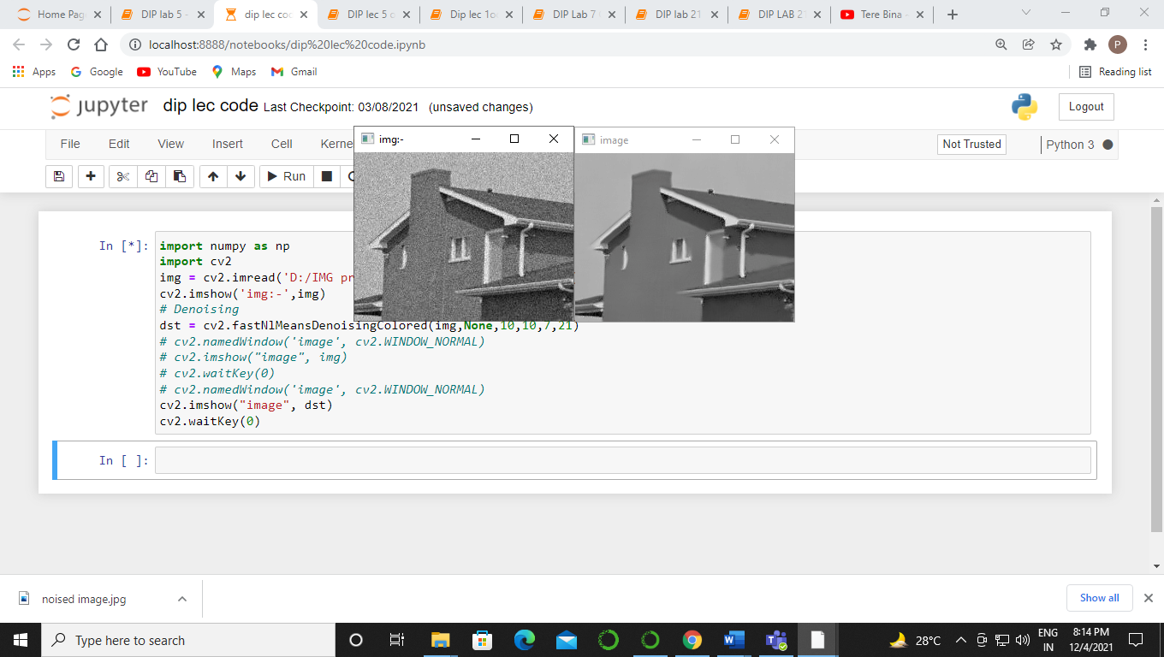

Q37. Write a Python program for image border using python api

Code:-

import cv2

import os

brdr = [0,0,0]

img1 = cv2.imread('D:/IMG processing lab/pngtree-cool-lightning-background-promotion-main-map-image_155563.jpg')

cv2.imshow("ex:-",img1)

constant= cv2.copyMakeBorder(img1,20,20,20,20,cv2.BORDER_CONSTANT,value=brdr)

cv2.imshow("Output:-",constant)

cv2.waitKey(0)

Output:-

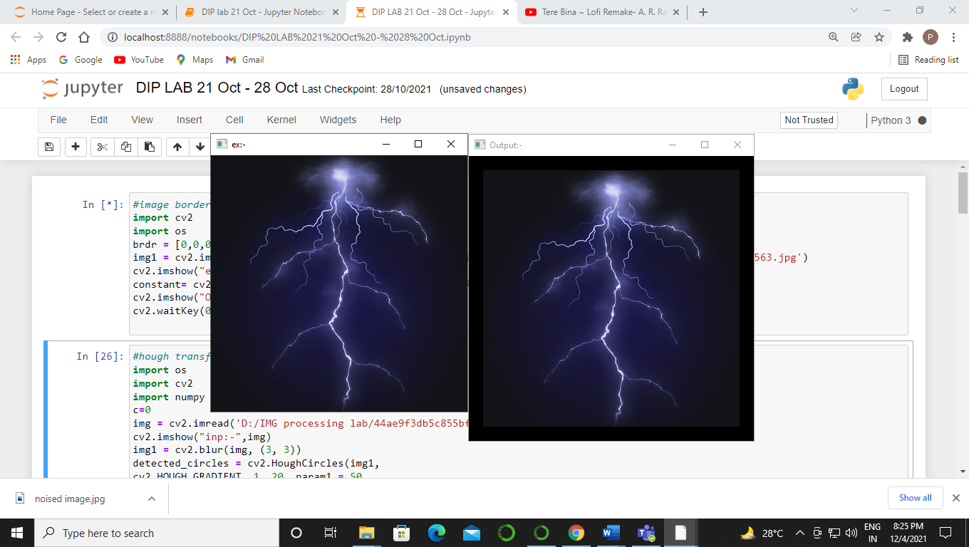

Q38. Write a Python program for hough transform circle detection.

Code:-

#hough transform circle detection

import os

import cv2

import numpy as np

c=0

img = cv2.imread('D:/IMG processing lab/44ae9f3db5c855bf0703058fba4f44fc.jpg',0)

cv2.imshow("inp:-",img)

img1 = cv2.blur(img, (3, 3))

detected_circles = cv2.HoughCircles(img1,

cv2.HOUGH_GRADIENT, 1, 20, param1 = 50,

param2 = 30, minRadius = 1, maxRadius = 40)

if detected_circles is not None:

detected_circles = np.uint16(np.around(detected_circles))

for pt in detected_circles[0, :]:

a, b, r = pt[0], pt[1], pt[2]

cv2.circle(img1, (a, b), r, (0, 255, 0), 2)

cv2.circle(img1, (a, b), 1, (0, 0, 255), 3)

c=c+1

cv2.imshow("Circle detection:-", img1)

cv2.waitKey(0)

print(c)

Output:-

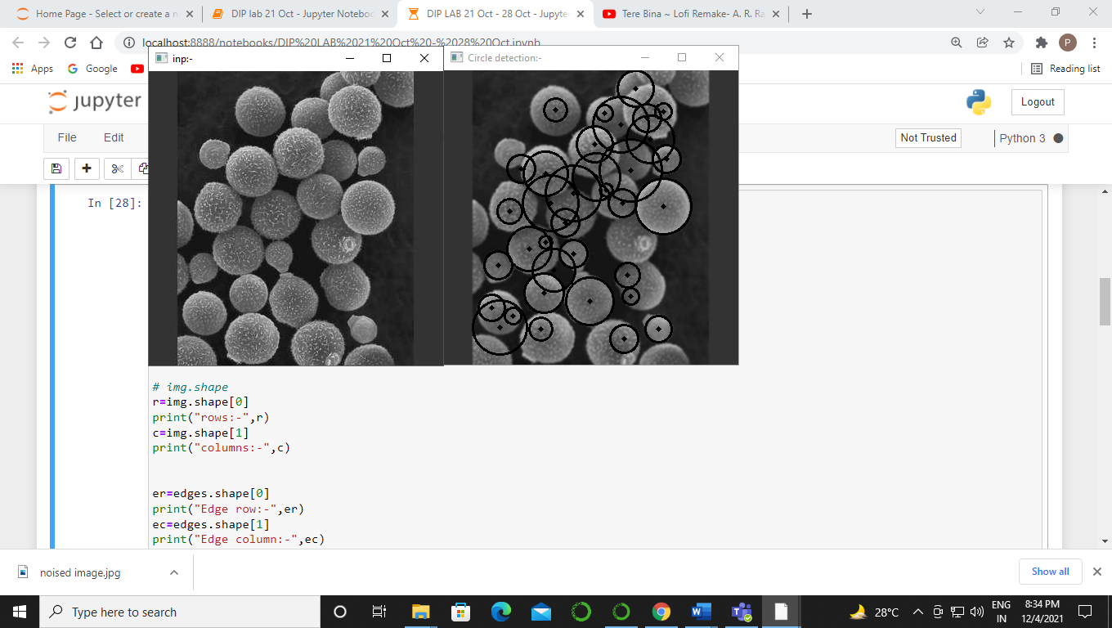

Q39. Write a Python program for water level detection of a full filled bottle

Code:-

#roi detction full bottle problem

import cv2

import numpy as np

img = cv2.imread('D:/IMG processing lab/MicrosoftTeams-image (7).png',0)

prep = img[30:900,258:510]

cv2.imshow('ROI img:-',prep)

edges = cv2.Canny(prep,60,200)

cv2.imshow('Edge:-',edges)

cv2.waitKey(0)

# img.shape

r=img.shape[0]

print("rows:-",r)

c=img.shape[1]

print("columns:-",c)

er=edges.shape[0]

print("Edge row:-",er)

ec=edges.shape[1]

print("Edge column:-",ec)

count=0

ar=[]

for i in range(edges.shape[0]):

for j in range(edges.shape[1]):

if (edges[i][j]==255):

ar.append(i)

count=count+1

print("[",i,"]","[",j,"]=",edges[i][j])

print(count)

list=[]

for i in range(edges.shape[0]):

list.append(ar.count(i))

print("row number",i,"",ar.count(i))

maximum_num_pixel =max(list)

print("The no of pixel in the edge", maximum_num_pixel)

print("Row no of water level edge",list.index(maximum_num_pixel))

Output:-

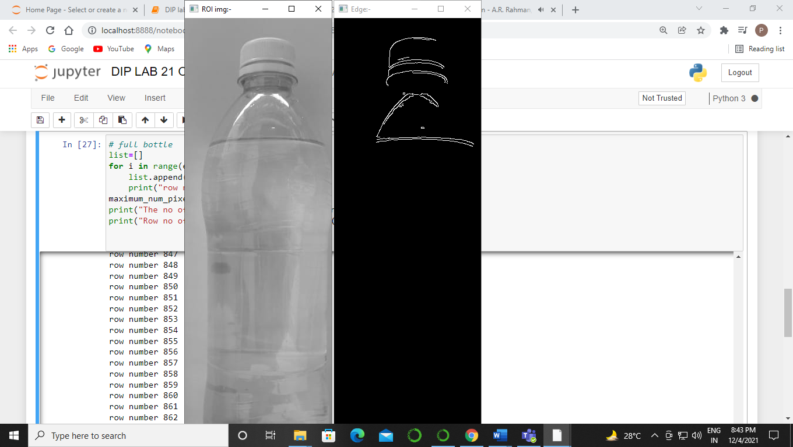

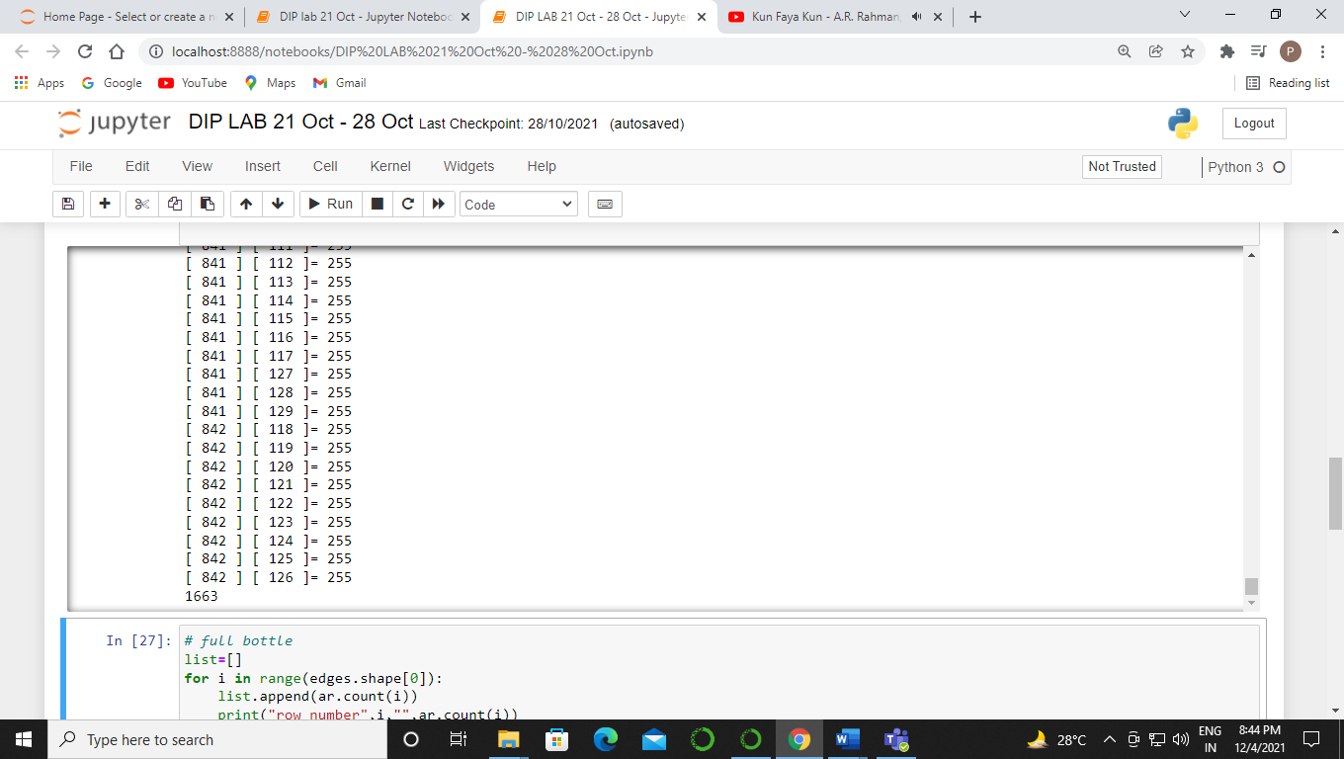

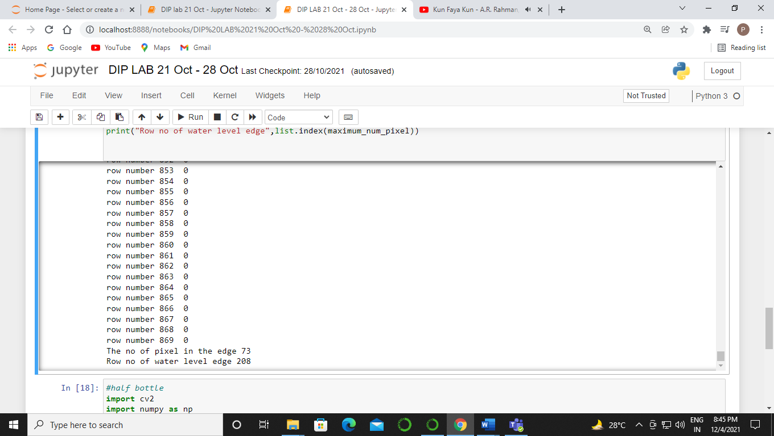

Q40. Write a Python program for water level detection of a half filled water

Code:-

#half bottle

import cv2

import numpy as np

img = cv2.imread('D:/IMG processing lab/MicrosoftTeams-image (8).png',0)

hprep = img[30:900,258:510]

cv2.imshow('ROI half bottle img:-',hprep)

hlfedges = cv2.Canny(hprep,50,100)

cv2.imshow('Edge:-',hlfedges)

cv2.waitKey(0)

# img.shape

hr=img.shape[0]

print("rows:-",hr)

hc=img.shape[1]

print("columns:-",hc)

her=edges.shape[0]

print("Edge row:-",her)

hec=edges.shape[1]

print("Edge column:-",hec)

Output:-

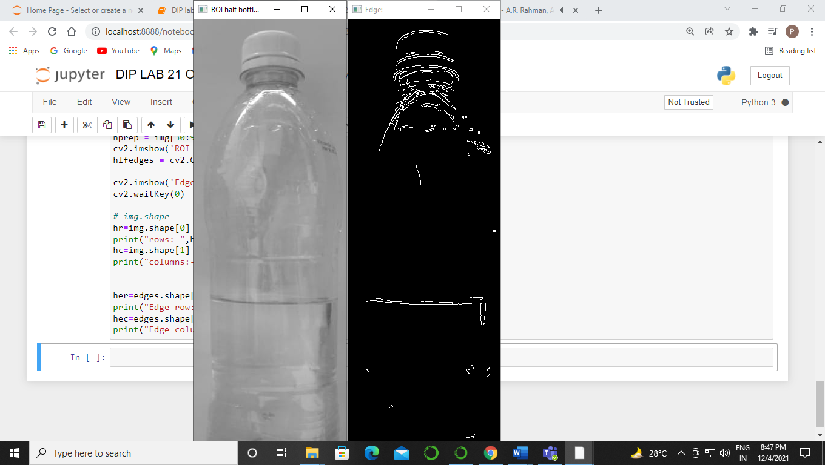

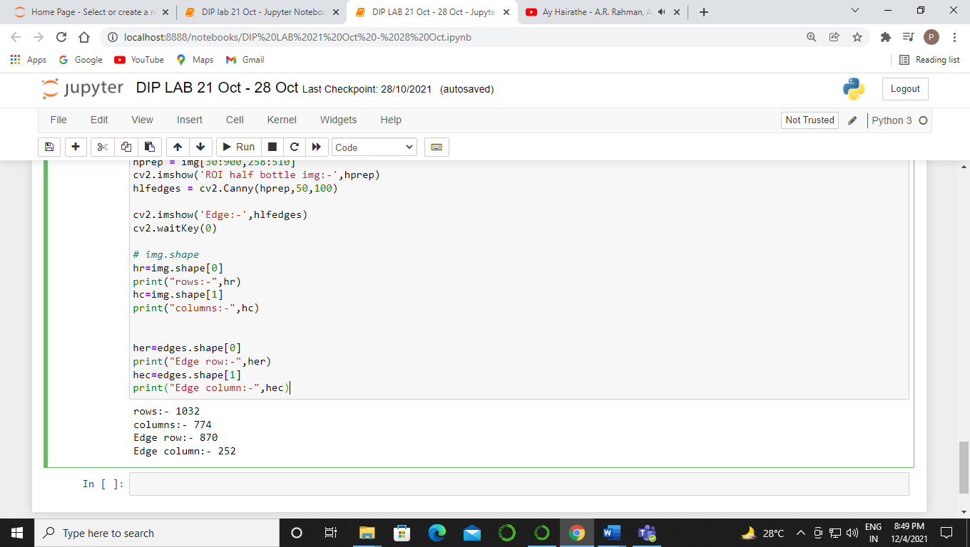

Q41. Write a Python program for selecting region of interest (ROI ) on a image.

Code:-

# Using selectROI function for clicking and draging the mouse to make bounding box on the image .

import cv2 as cv

img= cv.imread('C:/Users/prathmesha/Desktop/Presentation/ford-mustang-the-crew-2-4k.jpg')

roi = cv.selectROI(img)

print(roi)

crop = img[int(roi[1]):int(roi[1]+roi[3]),

int(roi[0]):int(roi[0]+roi[2])]

cv.imshow('cropped img:-',crop)

cv.waitKey(0)

Output:-

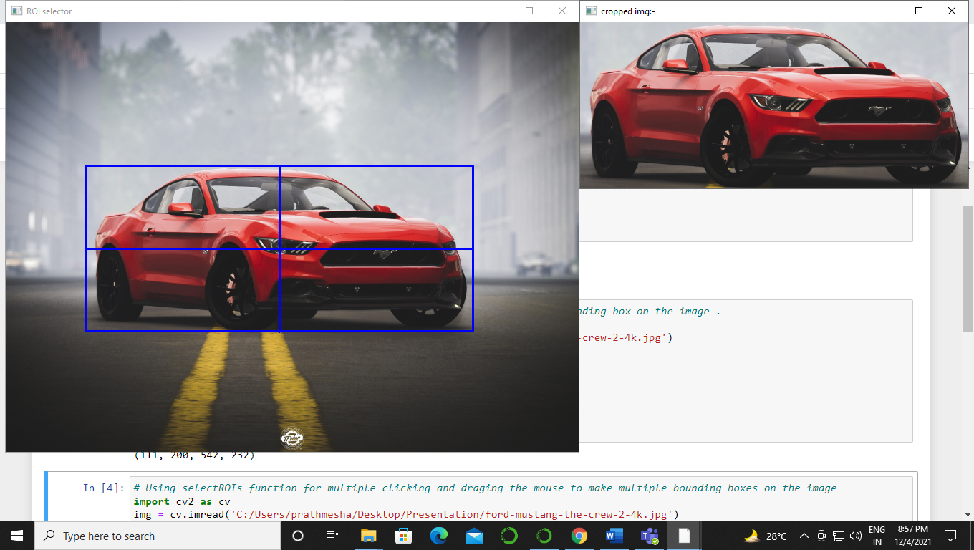

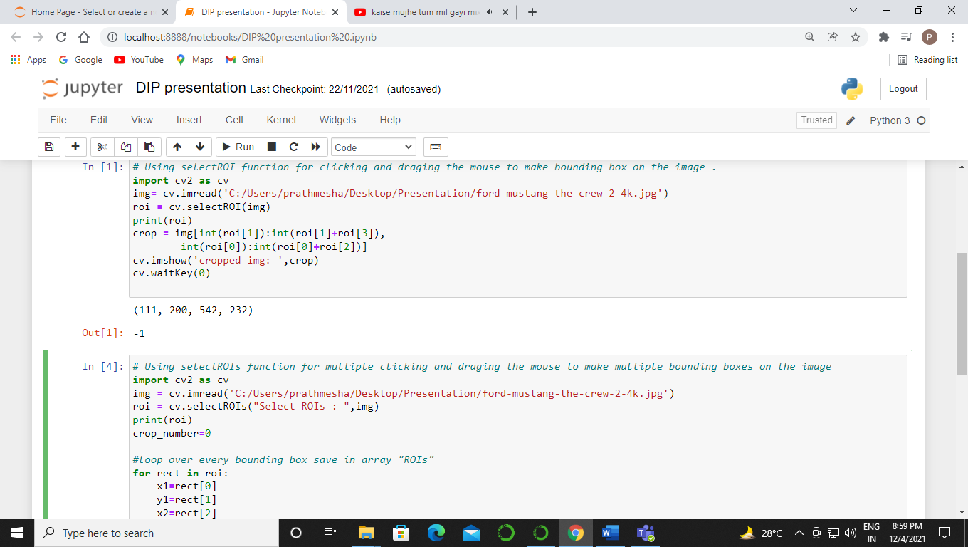

Q42. Write a Python program for selecting multiple region of interest (ROI) on a image

Code:-

# Using selectROIs function for multiple clicking and draging the mouse to make multiple bounding boxes on the image

import cv2 as cv

img = cv.imread('C:/Users/prathmesha/Desktop/Presentation/ford-mustang-the-crew-2-4k.jpg')

roi = cv.selectROIs("Select ROIs :-",img)

print(roi)

crop_number=0

#loop over every bounding box save in array "ROIs"

for rect in roi:

x1=rect[0]

y1=rect[1]

x2=rect[2]

y2=rect[3]

#crop roi from original image

img_roi=img[y1:y1+y2,x1:x1+x2]

#show cropped image

cv.imshow("crop"+str(crop_number),img_roi)

crop_number+=1

cv.waitKey(0)

Output:-

